https://jira.tcsbank.ru/browse/IN-575
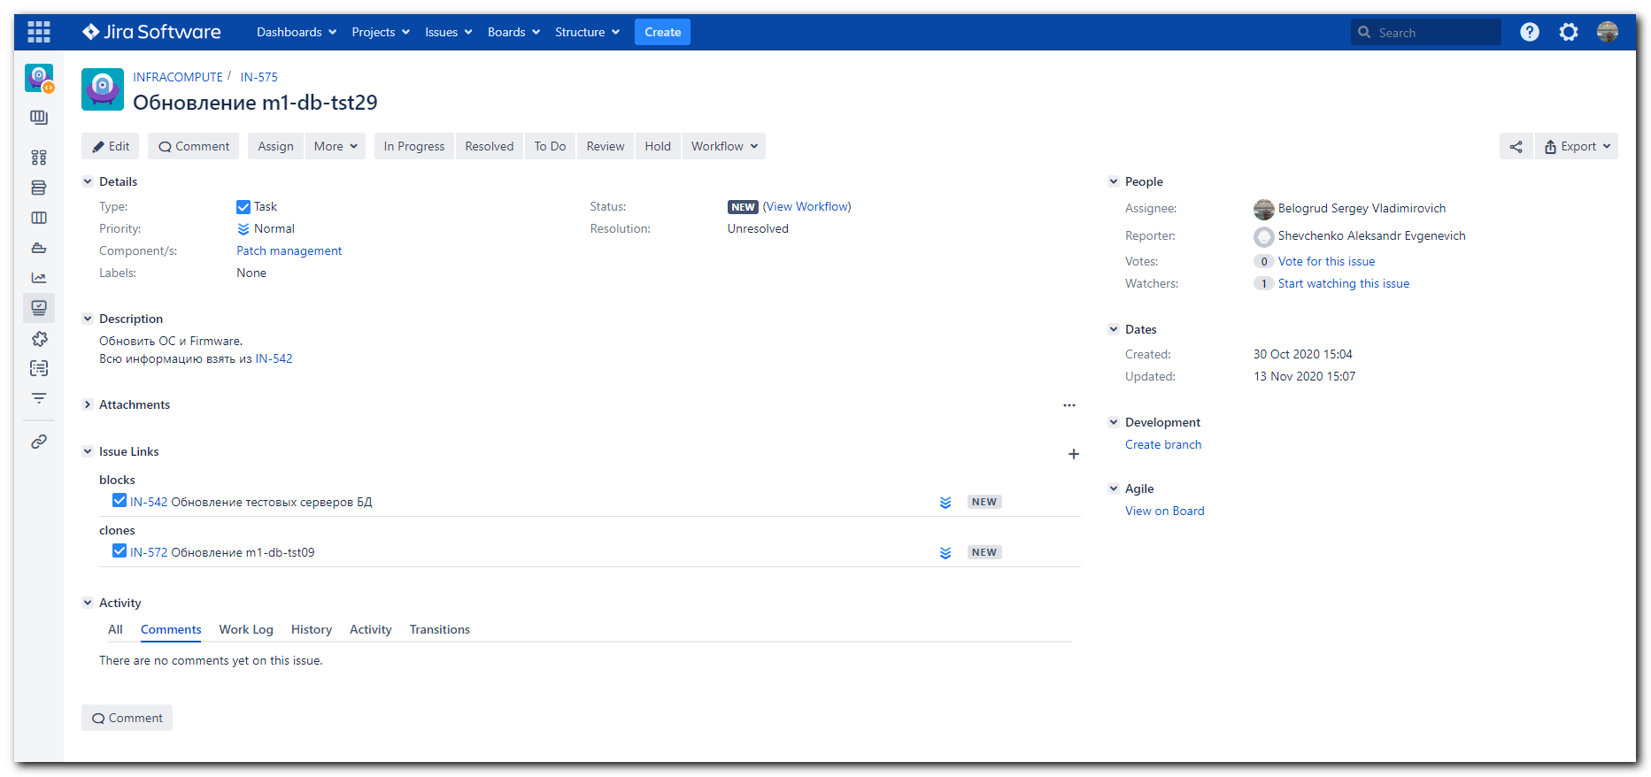

https://jira.tcsbank.ru/browse/IN-542
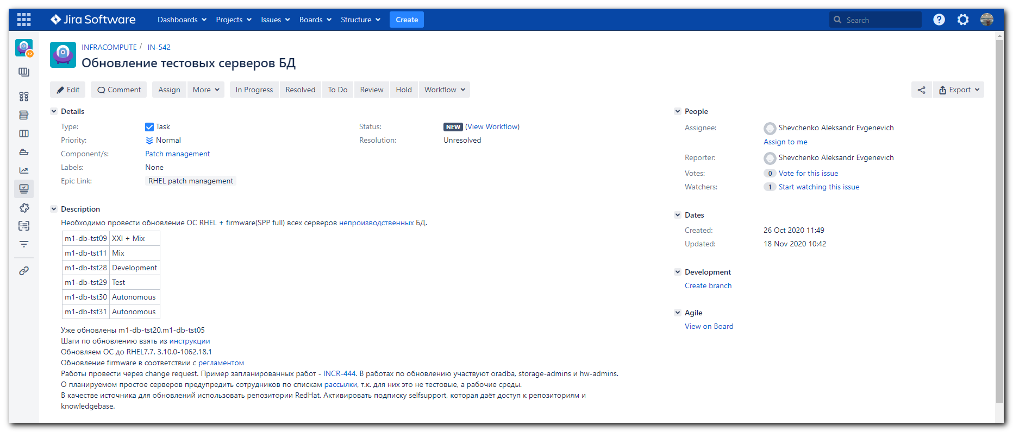
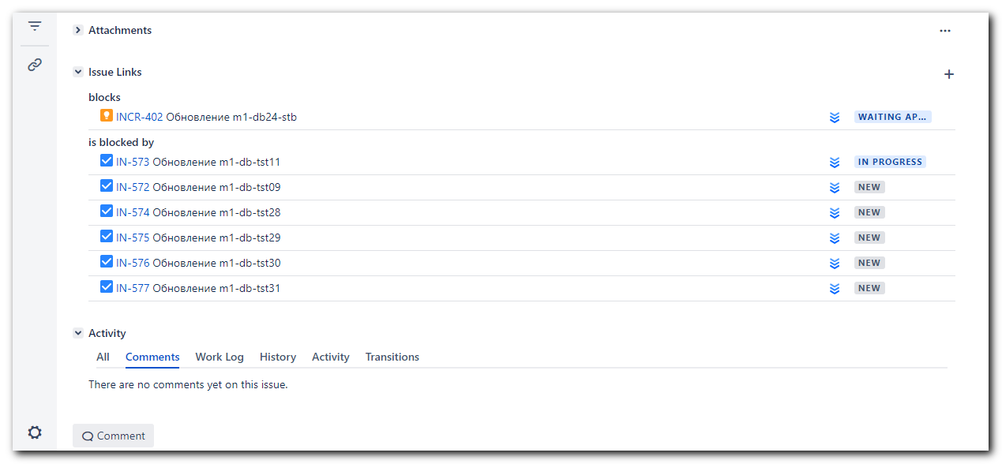
Шаги по обновлению взять из инструкции
Обновляем ОС до RHEL7.7, 3.10.0-1062.18.1
Обновление firmware в соответствии с регламентом
Работы провести через change request. Пример запланированных работ - INCR-444. В работах по обновлению участвуют oradba, storage-admins и hw-admins.
О планируемом простое серверов предупредить сотрудников по спискам рассылки, т.к. для них это не тестовые, а рабочие среды.
В качестве источника для обновлений использовать репозитории RedHat. Активировать подписку selfsupport, которая даёт доступ к репозиториям и knowledgebase.

https://wiki.tcsbank.ru/pages/viewpage.action?spaceKey=TECHSUPPORT&title=RHEL+update
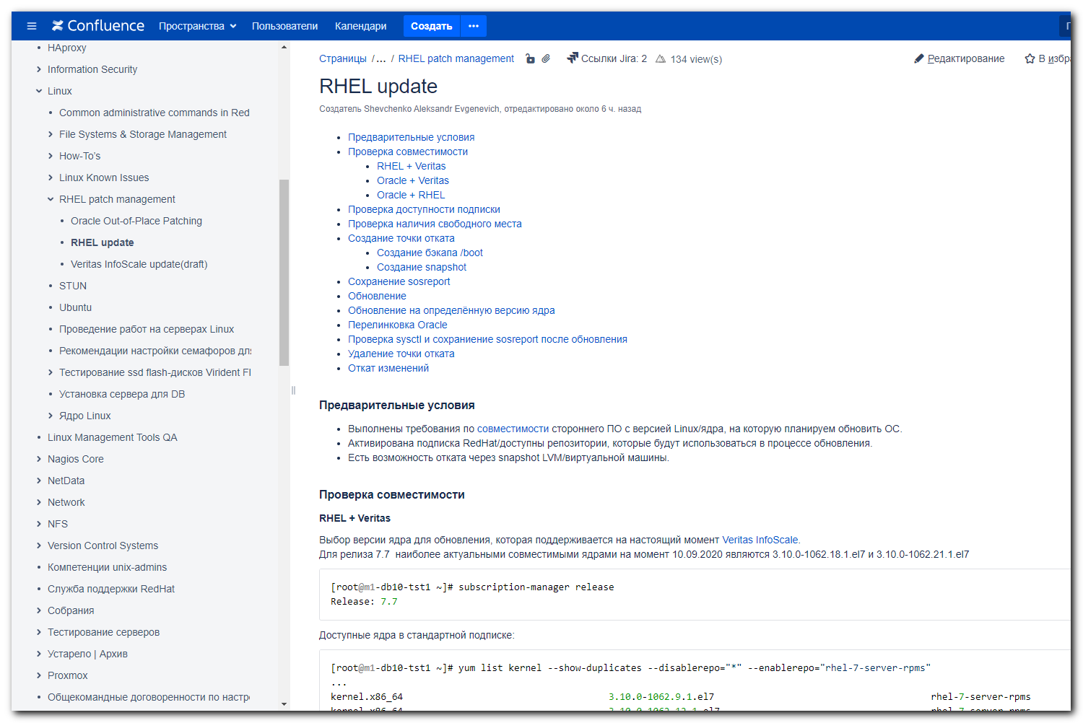

#
# https://access.redhat.com/documentation/en-us/red_hat_subscription_management/1/html/quick_registration_for_rhel/sub-cli
# And in Google docs "yum,rpm,subscription-manager"
#

[s.belogrud@TCS4357]# ssh bsv@m1-db-tst29
Warning: Permanently added 'm1-db-tst29' (RSA) to the list of known hosts.
Last login: Thu Aug 8 18:48:55 2019 from tcs4357.tcsbank.ru
[bsv@m1-db-tst29 ~]$ sudo -i
[sudo] password for bsv:
[17:04:27 root@m1-db-tst29 ~]# yum list kernel --show-duplicates --disablerepo="*" --enablerepo="rhel-7-server-rpms"
Loaded plugins: langpacks, product-id, search-disabled-repos, subscription-manager
This system is not registered with an entitlement server. You can use subscription-manager to register.

Error getting repository data for rhel-7-server-rpms, repository not found
[17:04:53 root@m1-db-tst29 ~]#

[18:45:47 root@m1-db-tst29 ~]# subscription-manager list
+-------------------------------------------+
Installed Product Status
+-------------------------------------------+
Product Name: Red Hat Enterprise Linux Server
Product ID: 69
Version: 7.5
Arch: x86_64
Status: Unknown
Status Details:
Starts:
Ends:

[18:45:50 root@m1-db-tst29 ~]# subscription-manager status
+-------------------------------------------+
System Status Details
+-------------------------------------------+
Overall Status: Unknown

[18:47:17 root@m1-db-tst29 ~]# egrep -e "^proxy_hostname|^proxy_port|^proxy_user|^proxy_password" /etc/rhsm/rhsm.conf
proxy_hostname =proxy.tcsbank.ru
proxy_port =8080
proxy_user =rhsm_user
proxy_password =6eKoEvNHFS5IycxhqH5W
[18:52:49 root@m1-db-tst29 ~]# read -s -p "Enter RHN Password: " RHN_PASSWORD ; subscription-manager register --username=tcsbank17012012 --password=$RHN_PASSWORD --auto-attach
Enter RHN Password: Registering to: subscription.rhsm.redhat.com:443/subscription
The system has been registered with ID: 524259f4-2fe3-4c06-af06-e8af1618a379
The registered system name is: m1-db-tst29.tcsbank.ru
Installed Product Current Status:
Product Name: Red Hat Enterprise Linux Server
Status: Subscribed

[18:55:55 root@m1-db-tst29 ~]# subscription-manager status
+-------------------------------------------+
System Status Details
+-------------------------------------------+
Overall Status: Current

[18:56:56 root@m1-db-tst29 ~]# subscription-manager list
+-------------------------------------------+
Installed Product Status
+-------------------------------------------+
Product Name: Red Hat Enterprise Linux Server
Product ID: 69
Version: 7.5
Arch: x86_64
Status: Subscribed
Status Details:
Starts: 11/22/2018
Ends: 11/22/2021

[18:57:07 root@m1-db-tst29 ~]# subscription-manager attach --pool=8a85f99c671cb397016740c9e5347049
This unit has already had the subscription matching pool ID "8a85f99c671cb397016740c9e5347049" attached.
[18:57:42 root@m1-db-tst29 ~]# subscription-manager list
+-------------------------------------------+
Installed Product Status
+-------------------------------------------+
Product Name: Red Hat Enterprise Linux Server
Product ID: 69
Version: 7.5
Arch: x86_64
Status: Subscribed
Status Details:
Starts: 11/22/2018
Ends: 11/22/2021

[18:58:05 root@m1-db-tst29 ~]# subscription-manager status
+-------------------------------------------+
System Status Details
+-------------------------------------------+
Overall Status: Current

[18:58:16 root@m1-db-tst29 ~]#

[18:58:16 root@m1-db-tst29 ~]# subscription-manager release --list
+-------------------------------------------+
Available Releases
+-------------------------------------------+
7.0
7.1
7.2
7.3
7.4
7.5
7.6
7.7
7.8
7.9
7Server
[19:11:12 root@m1-db-tst29 ~]#

................................................................................

[19:14:51 root@m1-db-tst29 ~]# export rootvg=$(lvs --noheadings -o vg_name -S lv_dm_path=`findmnt -r -n -o SOURCE /`| tr -d ' ')
[19:15:10 root@m1-db-tst29 ~]# vgs -S vg_name=$rootvg
VG #PV #LV #SN Attr VSize VFree
rootvg 1 5 0 wz--n- 1.09t 442.56g
[19:15:23 root@m1-db-tst29 ~]#

[19:15:29 root@m1-db-tst29 ~]# export rootvg=$(lvs --noheadings -o vg_name -S lv_dm_path=`findmnt -r -n -o SOURCE /`| tr -d ' ')
[19:15:50 root@m1-db-tst29 ~]# lvs -S "vg_name=$rootvg && lv_role=snapshot"
[19:16:02 root@m1-db-tst29 ~]#

# Now it’s working.
[16:57:58 root@m1-db-tst29 ~]# yum list kernel --show-duplicates --disablerepo="*" --enablerepo="rhel-7-server-rpms" | head
Loaded plugins: langpacks, product-id, search-disabled-repos, subscription-
: manager
Repodata is over 2 weeks old. Install yum-cron? Or run: yum makecache fast
Installed Packages
kernel.x86_64 3.10.0-693.17.1.el7 @anaconda/7.4
kernel.x86_64 3.10.0-862.14.4.el7 @rhel-7-server-rpms
Available Packages
kernel.x86_64 3.10.0-123.el7 rhel-7-server-rpms
kernel.x86_64 3.10.0-123.1.2.el7 rhel-7-server-rpms
kernel.x86_64 3.10.0-123.4.2.el7 rhel-7-server-rpms
kernel.x86_64 3.10.0-123.4.4.el7 rhel-7-server-rpms
[16:58:40 root@m1-db-tst29 ~]#

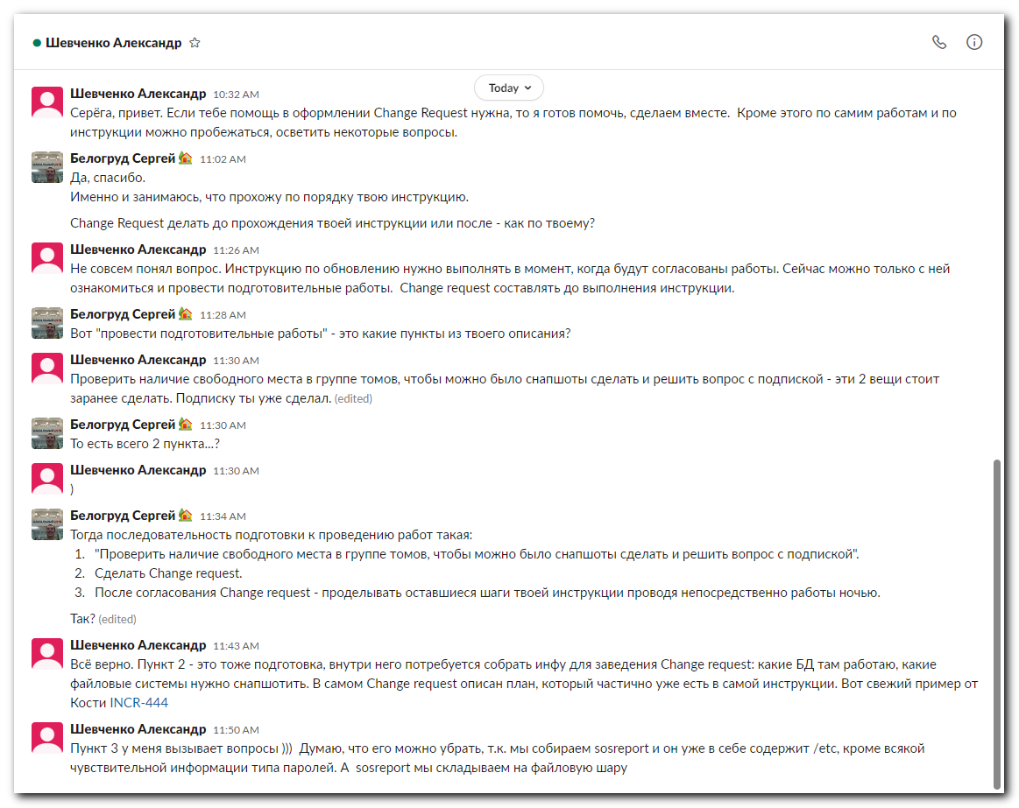
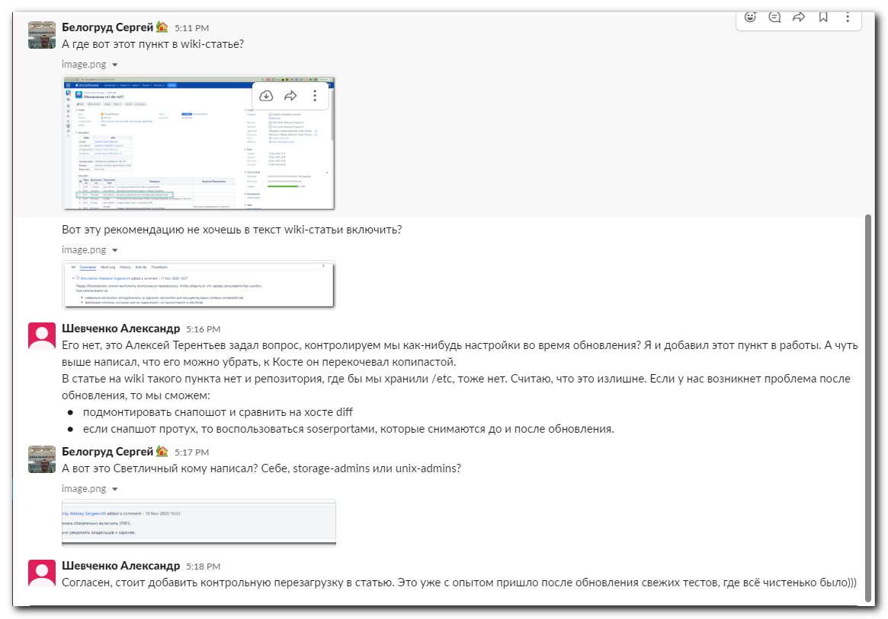
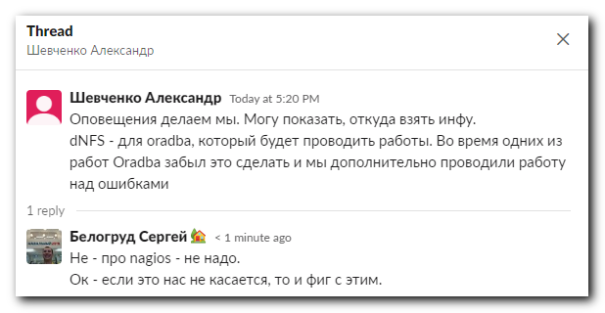

https://jira.tcsbank.ru/browse/INCR-444
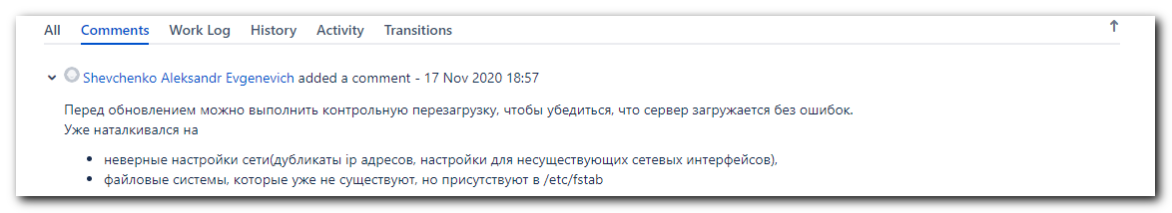

# Создвать Change request следует через обычный Create и копируя содержимое полей с ранее существовавшей аналогичной Jira-задачи.
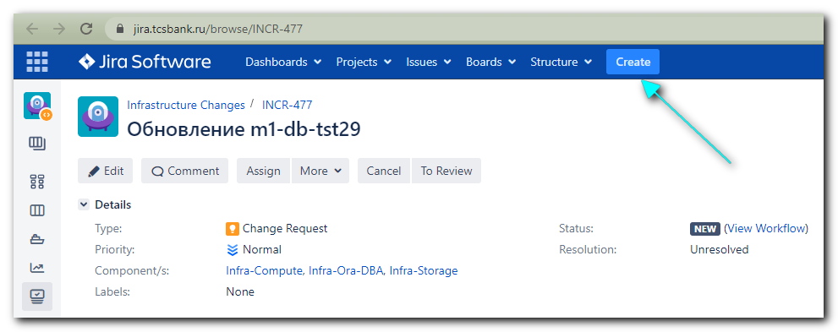

# Fill in appropriate fields.
# Some of them could be copied from template (original task).
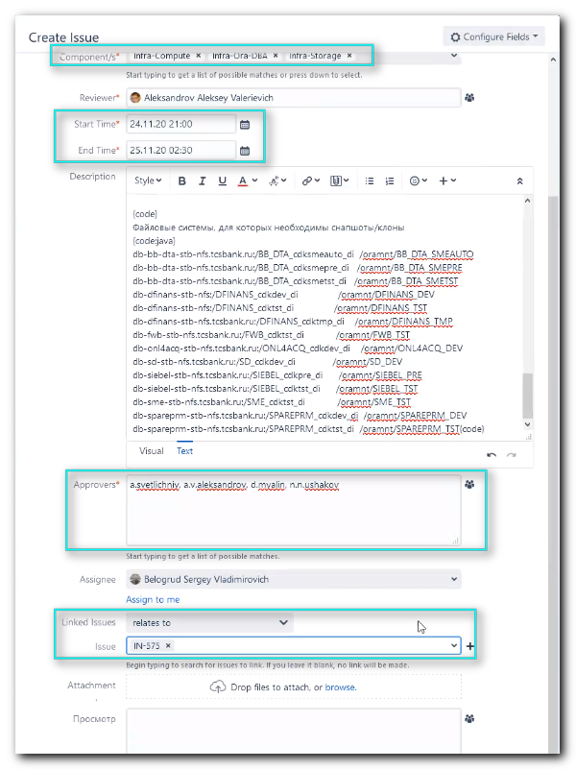

# Если так сделать, то то что получится будет со сломанными настройками (как будто уже всеми проверенная и принятая и т.п.).
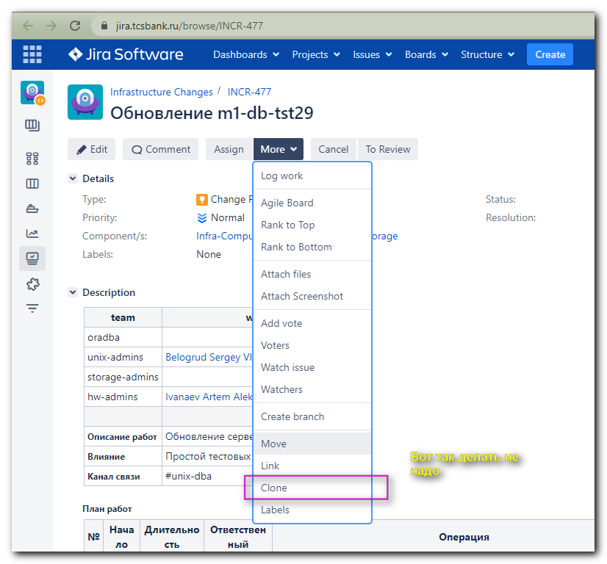

# Write correct server names.
# Correct time - when this works start and when other steps will start.
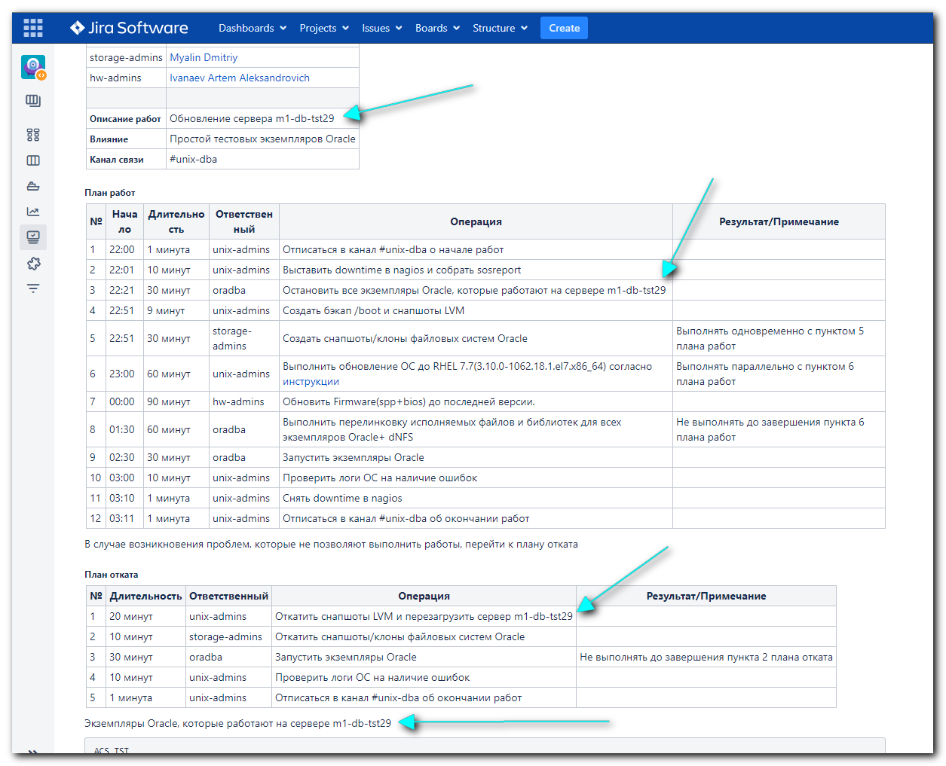

#
# Get information about database names, that working at this server.
#
[14:16:52 root@m1-db-tst29 ~]# findmnt -t nfs -o TARGET | grep -ie "oramnt" | sed -e 's/^\/oramnt\///'
ACS_TST
ACS2_TST
WOF_TST
PRM_TST
PRIME4_TST
BUFF_TST
LOYALTY_TST
PRIME4_OLT
TPG_TST
BIO_TST
db_tst_arch
WOF_TST2
[14:17:49 root@m1-db-tst29 ~]#

[18:29:04 root@m1-db-tst29 ~]# findmnt -t nfs -o SOURCE,TARGET | grep -ie "oramnt"
db-acs-stb-nfs.tcsbank.ru:/ACS_cdktst_di /oramnt/ACS_TST
db-acs2-stb-nfs.tcsbank.ru:/ACS2_cdktst_di /oramnt/ACS2_TST
db-wof-stb-nfs.tcsbank.ru:/WOF_cdktst_di /oramnt/WOF_TST
db-prm-stb-nfs.tcsbank.ru:/PRM_cdktst_di /oramnt/PRM_TST
db-prime4-stb-nfs.tcsbank.ru:/PRIME4_cdktst_di /oramnt/PRIME4_TST
db-buff-stb-nfs.tcsbank.ru:/BUFF_cdktst_di /oramnt/BUFF_TST
db-loyalty-stb-nfs.tcsbank.ru:/LOYALTY_cdktst_di /oramnt/LOYALTY_TST
db-prime4-stb-nfs.tcsbank.ru:/PRIME4_cdkolt_di /oramnt/PRIME4_OLT
db-tpg-stb-nfs.tcsbank.ru:/TPG_cdktst_di /oramnt/TPG_TST
db-bio-stb-nfs.tcsbank.ru:/BIO_cdktst_di /oramnt/BIO_TST
db-buff-stb-nfs:/db_tst_arch /oramnt/db_tst_arch
db-wof-stb-nfs.tcsbank.ru:/WOF_cdktst2_di /oramnt/WOF_TST2
[18:29:23 root@m1-db-tst29 ~]#

#
# And write it here.
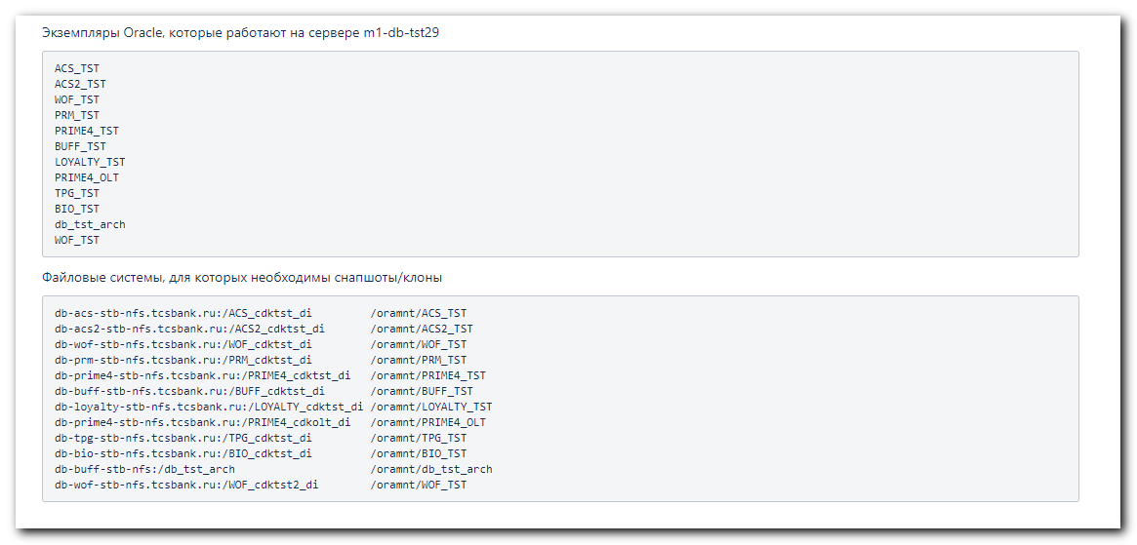

#
# Information about databases on this server.
# https://wiki.tcsbank.ru/pages/viewpage.action?pageId=289558905
#
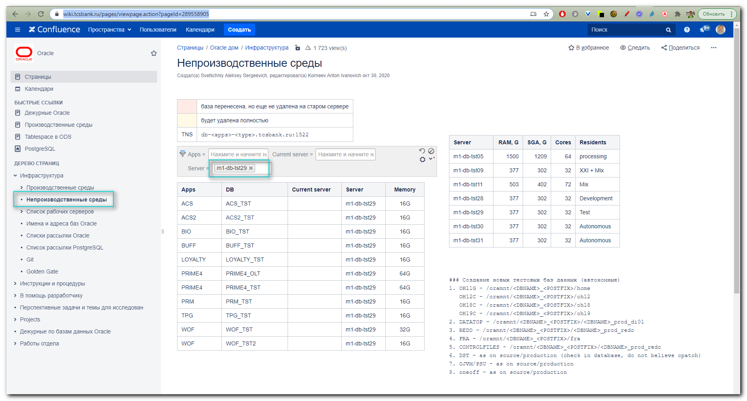

#
# Here is info about mailing list for every database.
# https://wiki.tcsbank.ru/pages/viewpage.action?pageId=229471595
#
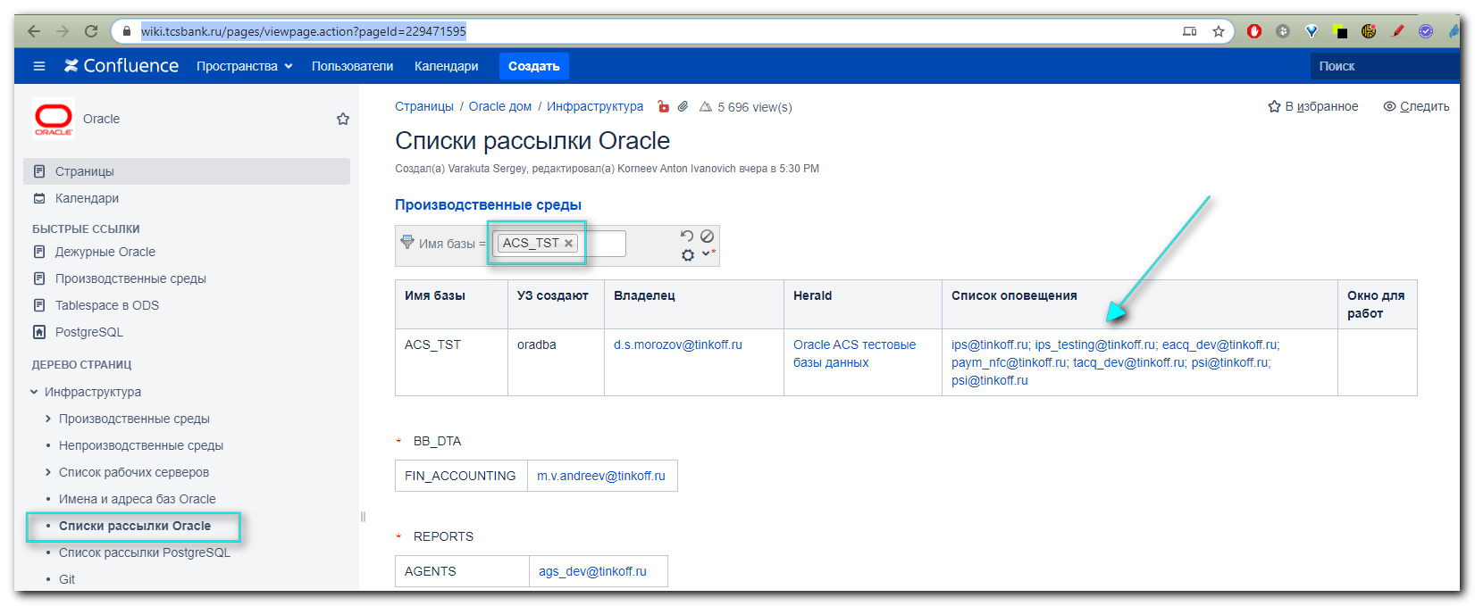

#
# To send task to Aleksandrov to review.
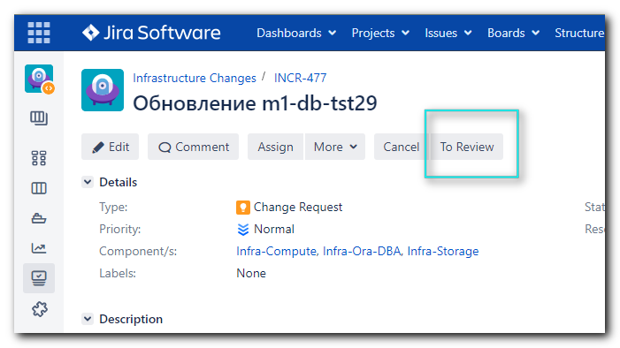

# После того, как Александров сделал Review (и, видимо нажал куда-то). Статус задачи с “Ready for Review”, сменился на “Waiting Approval”.
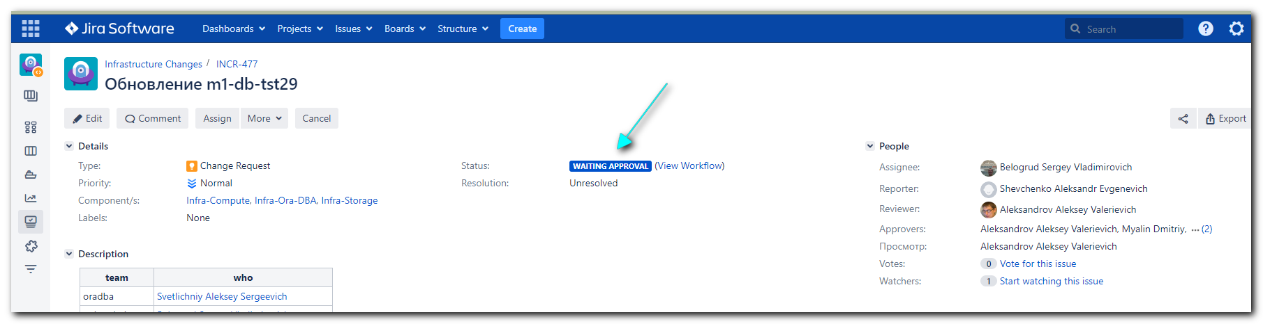

#
# Рассылаю запросы в Слак на Approve. Светличный, Мялин, Ушаков и отдельное уведомление Иванаеву Артёму.
#

Белогруд Сергей:house_with_garden: 12:34 PM
Привет Алексей.
Обрати пожалуйста внимание.
Вечером-ночью со вторника на среду планируются работы. Ты среди тех, от кого требуется Approve.
Без твоего Approve работ не будет.
https://jira.tcsbank.ru/browse/INCR-477

Белогруд Сергей:house_with_garden: 12:38 PM
Привет Артём.
Обрати пожалуйста внимание.
Вечером-ночью со вторника на среду планируются работы. Ты среди тех, кто принимает участие в работах.
Без твоего согласия работ не будет. Я направил зарос на Approve Ушакову Никите. Поэтому, если у тебя нет возможности участия в работах - проинформируй пожалуйста его об этом.
https://jira.tcsbank.ru/browse/INCR-477

Видимо когда все сделали Approve - статус задачи меняется на “Planning”.
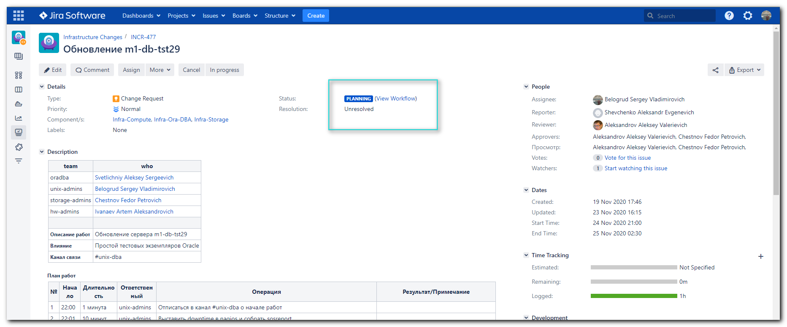

Сбор адресов и рассылка письма.
https://wiki.tcsbank.ru/pages/viewpage.action?pageId=229471595
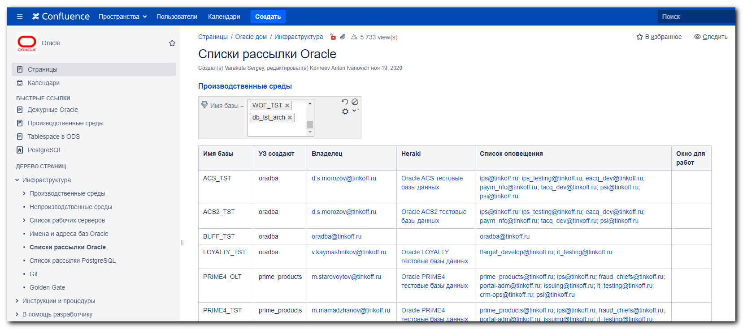

Имя базы УЗ создают Владелец Herald Список оповещения Окно для работ
ACS_TST oradba d.s.morozov@tinkoff.ru Oracle ACS тестовые базы данных ips@tinkoff.ru; ips_testing@tinkoff.ru; eacq_dev@tinkoff.ru; paym_nfc@tinkoff.ru; tacq_dev@tinkoff.ru; psi@tinkoff.ru; psi@tinkoff.ru
ACS2_TST oradba d.s.morozov@tinkoff.ru Oracle ACS2 тестовые базы данных ips@tinkoff.ru; ips_testing@tinkoff.ru; eacq_dev@tinkoff.ru; paym_nfc@tinkoff.ru; tacq_dev@tinkoff.ru; psi@tinkoff.ru
BUFF_TST oradba oradba@tinkoff.ru
oradba@tinkoff.ru
LOYALTY_TST oradba v.kaymashnikov@tinkoff.ru Oracle LOYALTY тестовые базы данных ttarget_develop@tinkoff.ru; it_testing@tinkoff.ru
PRIME4_OLT prime_products m.starovoytov@tinkoff.ru Oracle PRIME4 тестовые базы данных prime_products@tinkoff.ru; ips@tinkoff.ru; fraud_chiefs@tinkoff.ru; portal-adm@tinkoff.ru; issuing@tinkoff.ru; it_testing@tinkoff.ru; crm-ops@tinkoff.ru; psi@tinkoff.ru
PRIME4_TST prime_products
m.mamadzhanov@tinkoff.ru

Oracle PRIME4 тестовые базы данных prime_products@tinkoff.ru; ips@tinkoff.ru; fraud_chiefs@tinkoff.ru; portal-adm@tinkoff.ru; issuing@tinkoff.ru; it_testing@tinkoff.ru; crm-ops@tinkoff.ru; psi@tinkoff.ru; trading-api@tinkoff.ru; incident_testing@tinkoff.ru
PRM_TST oradba v.volobuev@tinkoff.ru Oracle PRM тестовые базы данных prm@tinkoff.ru
TPG_TST oradba p.silaev@tinkoff.ru Oracle TPG тестовые базы данных paym_telco@tinkoff.ru; mvno_release@tinkoff.ru
WOF_TST oradba a.mynkov@tinkoff.ru Oracle WOF тестовые базы данных weboffice_dev@tinkoff.ru; weboffice_test@tinkoff.ru; telephony-dev@tinkoff.ru; voicebiometry-dev@tinkoff.ru; telephony-devops@tinkoff.ru; telephony-test@tinkoff.ru

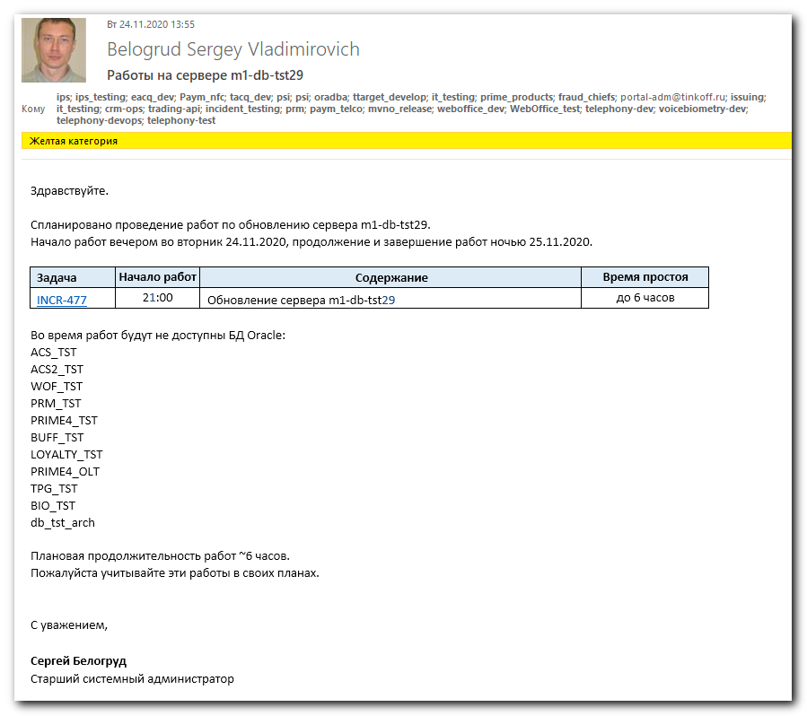

Здравствуйте.

Спланировано проведение работ по обновлению сервера m1-db-tst29.
Начало работ вечером во вторник 24.11.2020, продолжение и завершение работ ночью 25.11.2020.

Задача Начало работ Содержание Время простоя
INCR-477
21:00 Обновление сервера m1-db-tst29 до 6 часов

Во время работ будут не доступны БД Oracle:
ACS_TST
ACS2_TST
WOF_TST
PRM_TST
PRIME4_TST
BUFF_TST
LOYALTY_TST
PRIME4_OLT
TPG_TST
BIO_TST
db_tst_arch

Плановая продолжительность работ ~6 часов.
Пожалуйста учитывайте эти работы в своих планах.

С уважением,

Сергей Белогруд
Старший системный администратор

Перед непосредственным началом работ -> нажать в Jira-задаче “In progress”.

................................................................................

#
# https://access.redhat.com/documentation/en-us/red_hat_subscription_management/1/html/quick_registration_for_rhel/sub-cli
# And in Google docs "yum,rpm,subscription-manager"
#

[s.belogrud@TCS4357]# ssh bsv@m1-db-tst29
Warning: Permanently added 'm1-db-tst29' (RSA) to the list of known hosts.
Last login: Thu Aug 8 18:48:55 2019 from tcs4357.tcsbank.ru
[bsv@m1-db-tst29 ~]$ sudo -i
[sudo] password for bsv:
[17:04:27 root@m1-db-tst29 ~]# yum list kernel --show-duplicates --disablerepo="*" --enablerepo="rhel-7-server-rpms"
Loaded plugins: langpacks, product-id, search-disabled-repos, subscription-manager
This system is not registered with an entitlement server. You can use subscription-manager to register.

Error getting repository data for rhel-7-server-rpms, repository not found
[17:04:53 root@m1-db-tst29 ~]# cat

[18:45:47 root@m1-db-tst29 ~]# subscription-manager list
+-------------------------------------------+
Installed Product Status
+-------------------------------------------+
Product Name: Red Hat Enterprise Linux Server
Product ID: 69
Version: 7.5
Arch: x86_64
Status: Unknown
Status Details:
Starts:
Ends:

[18:45:50 root@m1-db-tst29 ~]# subscription-manager status
+-------------------------------------------+
System Status Details
+-------------------------------------------+
Overall Status: Unknown

[18:47:17 root@m1-db-tst29 ~]# egrep -e "^proxy_hostname|^proxy_port|^proxy_user|^proxy_password" /etc/rhsm/rhsm.conf
proxy_hostname =proxy.tcsbank.ru
proxy_port =8080
proxy_user =rhsm_user
proxy_password =6eKoEvNHFS5IycxhqH5W
[18:52:49 root@m1-db-tst29 ~]# read -s -p "Enter RHN Password: " RHN_PASSWORD ; subscription-manager register --username=tcsbank17012012 --password=$RHN_PASSWORD --auto-attach
Enter RHN Password: Registering to: subscription.rhsm.redhat.com:443/subscription
The system has been registered with ID: 524259f4-2fe3-4c06-af06-e8af1618a379
The registered system name is: m1-db-tst29.tcsbank.ru
Installed Product Current Status:
Product Name: Red Hat Enterprise Linux Server
Status: Subscribed

[18:55:55 root@m1-db-tst29 ~]# subscription-manager status
+-------------------------------------------+
System Status Details
+-------------------------------------------+
Overall Status: Current

[18:56:56 root@m1-db-tst29 ~]# subscription-manager list
+-------------------------------------------+
Installed Product Status
+-------------------------------------------+
Product Name: Red Hat Enterprise Linux Server
Product ID: 69
Version: 7.5
Arch: x86_64
Status: Subscribed
Status Details:
Starts: 11/22/2018
Ends: 11/22/2021

[18:57:07 root@m1-db-tst29 ~]# subscription-manager attach --pool=8a85f99c671cb397016740c9e5347049
This unit has already had the subscription matching pool ID "8a85f99c671cb397016740c9e5347049" attached.
[18:57:42 root@m1-db-tst29 ~]# subscription-manager list
+-------------------------------------------+
Installed Product Status
+-------------------------------------------+
Product Name: Red Hat Enterprise Linux Server
Product ID: 69
Version: 7.5
Arch: x86_64
Status: Subscribed
Status Details:
Starts: 11/22/2018
Ends: 11/22/2021

[18:58:05 root@m1-db-tst29 ~]# subscription-manager status
+-------------------------------------------+
System Status Details
+-------------------------------------------+
Overall Status: Current

[18:58:16 root@m1-db-tst29 ~]#

[18:58:16 root@m1-db-tst29 ~]# subscription-manager release --list
+-------------------------------------------+
Available Releases
+-------------------------------------------+
7.0
7.1
7.2
7.3
7.4
7.5
7.6
7.7
7.8
7.9
7Server
[19:11:12 root@m1-db-tst29 ~]#

................................................................................

[19:14:51 root@m1-db-tst29 ~]# export rootvg=$(lvs --noheadings -o vg_name -S lv_dm_path=`findmnt -r -n -o SOURCE /`| tr -d ' ')
[19:15:10 root@m1-db-tst29 ~]# vgs -S vg_name=$rootvg
VG #PV #LV #SN Attr VSize VFree
rootvg 1 5 0 wz--n- 1.09t 442.56g
[19:15:23 root@m1-db-tst29 ~]#

[19:15:29 root@m1-db-tst29 ~]# export rootvg=$(lvs --noheadings -o vg_name -S lv_dm_path=`findmnt -r -n -o SOURCE /`| tr -d ' ')
[19:15:50 root@m1-db-tst29 ~]# lvs -S "vg_name=$rootvg && lv_role=snapshot"
[19:16:02 root@m1-db-tst29 ~]#

................................................................................

[16:57:58 root@m1-db-tst29 ~]# yum list kernel --show-duplicates --disablerepo="*" --enablerepo="rhel-7-server-rpms" | head
Loaded plugins: langpacks, product-id, search-disabled-repos, subscription-
: manager
Repodata is over 2 weeks old. Install yum-cron? Or run: yum makecache fast
Installed Packages
kernel.x86_64 3.10.0-693.17.1.el7 @anaconda/7.4
kernel.x86_64 3.10.0-862.14.4.el7 @rhel-7-server-rpms
Available Packages
kernel.x86_64 3.10.0-123.el7 rhel-7-server-rpms
kernel.x86_64 3.10.0-123.1.2.el7 rhel-7-server-rpms
kernel.x86_64 3.10.0-123.4.2.el7 rhel-7-server-rpms
kernel.x86_64 3.10.0-123.4.4.el7 rhel-7-server-rpms
[16:58:40 root@m1-db-tst29 ~]#

................................................................................
#
# 20201124
#

[21:04:17 root@m1-db-tst29 ~]# subscription-manager status
+-------------------------------------------+
System Status Details
+-------------------------------------------+
Overall Status: Current

[21:05:16 root@m1-db-tst29 ~]# subscription-manager release --list
+-------------------------------------------+
Available Releases
+-------------------------------------------+
7.0
7.1
7.2
7.3
7.4
7.5
7.6
7.7
7.8
7.9
7Server
[21:05:32 root@m1-db-tst29 ~]# subscription-manager list
+-------------------------------------------+
Installed Product Status
+-------------------------------------------+
Product Name: Red Hat Enterprise Linux Server
Product ID: 69
Version: 7.5
Arch: x86_64
Status: Subscribed
Status Details:
Starts: 11/22/2018
Ends: 11/22/2021

[21:05:55 root@m1-db-tst29 ~]#

[21:05:55 root@m1-db-tst29 ~]# export rootvg=$(lvs --noheadings -o vg_name -S lv_dm_path=`findmnt -r -n -o SOURCE /`| tr -d ' ')
[21:11:54 root@m1-db-tst29 ~]# vgs -S vg_name=$rootvg
VG #PV #LV #SN Attr VSize VFree
rootvg 1 5 0 wz--n- 1.09t 442.56g
[21:12:11 root@m1-db-tst29 ~]# export rootvg=$(lvs --noheadings -o vg_name -S lv_dm_path=`findmnt -r -n -o SOURCE /`| tr -d ' ')
[21:12:25 root@m1-db-tst29 ~]# lvs -S "vg_name=$rootvg && lv_role=snapshot"
[21:12:35 root@m1-db-tst29 ~]#

[21:14:38 root@m1-db-tst29 ~]# mkdir -p /mnt/techsupport; mount -t nfs fs-nfsmb3.tcsbank.ru:/db_sosreport /mnt/techsupport -o rw,bg,vers=3,tcp,timeo=600,rsize=65536,wsize=65536,hard; mkdir /mnt/techsupport/sosreport/`uname -n`; /usr/sbin/sosreport --batch --tmp-dir=/mnt/techsupport/sosreport/`uname -n`; umount /mnt/techsupport

sosreport (version 3.5)

This command will collect diagnostic and configuration information from
this Red Hat Enterprise Linux system and installed applications.

An archive containing the collected information will be generated in
/mnt/techsupport/sosreport/m1-db-tst29.tcsbank.ru/sos.Gu4eLO and may be
provided to a Red Hat support representative.

Any information provided to Red Hat will be treated in accordance with
the published support policies at:

https://access.redhat.com/support/

The generated archive may contain data considered sensitive and its
content should be reviewed by the originating organization before being
passed to any third party.

No changes will be made to system configuration.

Setting up archive ...
Setting up plugins ...
caught exception in plugin method "grub2.setup()"
writing traceback to sos_logs/grub2-plugin-errors.txt
Running plugins. Please wait ...

Running 1/89: abrt...
Running 2/89: anaconda...
Running 3/89: anacron...
Running 4/89: ata...
Running 5/89: auditd...
Running 6/89: autofs...
Running 7/89: block...
Running 8/89: boot...
Running 9/89: cgroups...
Running 10/89: cron...
Running 11/89: crypto...
Running 12/89: dbus...
Running 13/89: devicemapper...
Running 14/89: devices...
Running 15/89: dmraid...
Running 16/89: dracut...
Running 17/89: filesys...
Running 18/89: firewalld...
Running 19/89: general...
Running 20/89: grub2...
Running 21/89: hardware...
Running 22/89: hts...
Running 23/89: i18n...
Running 24/89: infosec...
Running 25/89: ipa...
Running 26/89: jars...
Running 27/89: java...
Running 28/89: kdump...
Running 29/89: kernel...
Running 30/89: keyutils...
Running 31/89: kpatch...
Running 32/89: krb5...
Running 33/89: kvm...
Running 34/89: last...
Running 35/89: ldap...
Running 36/89: libraries...
Running 37/89: libvirt...
Running 38/89: logrotate...
Running 39/89: logs...
Running 40/89: lsbrelease...
Running 41/89: lvm2...
Running 42/89: md...
Running 43/89: megacli...
Running 44/89: memory...
Running 45/89: mrggrid...
Running 46/89: mrgmessg...
Running 47/89: multipath...
Running 48/89: networking...
Running 49/89: nfs...
Running 50/89: nis...
Running 51/89: nss...
Running 52/89: ntb...
Running 53/89: ntp...
Running 54/89: oddjob...
Running 55/89: openhpi...
Running 56/89: openshift...
Running 57/89: openssl...
Running 58/89: pam...
Running 59/89: pci...
Running 60/89: perl...
Running 61/89: postfix...
Running 62/89: process...
Running 63/89: processor...
Running 64/89: psacct...
Running 65/89: puppet...
Running 66/89: python...
Running 67/89: rpm...
Running 68/89: samba...
Running 69/89: sar...
Running 70/89: scsi...
Running 71/89: selinux...
Running 72/89: services...
Running 73/89: soundcard...
Running 74/89: ssh...
Running 75/89: sssd...
Running 76/89: subscription_manager...
Running 77/89: system...
Running 78/89: systemd...
Running 79/89: systemtap...
Running 80/89: sysvipc...
Running 81/89: teamd...
Running 82/89: tuned...
Running 83/89: udev...
Running 84/89: usb...
Running 85/89: vhostmd...
Running 86/89: x11...
Running 87/89: xen...
Running 88/89: xfs...
Running 89/89: yum...

Creating compressed archive...

Your sosreport has been generated and saved in:
/mnt/techsupport/sosreport/m1-db-tst29.tcsbank.ru/sosreport-m1-db-tst29.tcsbank.ru-20201124211452.tar.xz

The checksum is: 43afe2766269c7cbbbfbca8b44820d47

Please send this file to your support representative.

[21:18:53 root@m1-db-tst29 ~]#

................................................................................

[21:18:53 root@m1-db-tst29 ~]# mkdir /var/stage/
[21:28:14 root@m1-db-tst29 ~]# tar -czvf /var/stage/boot_backup.tgz /boot
tar: Removing leading `/' from member names
/boot/
/boot/symvers-3.10.0-862.14.4.el7.x86_64.gz
/boot/initramfs-3.10.0-862.14.4.el7.x86_64.img
/boot/symvers-3.10.0-693.17.1.el7.x86_64.gz
/boot/System.map-3.10.0-693.17.1.el7.x86_64
/boot/grub2/
/boot/grub2/grubenv
/boot/vmlinuz-3.10.0-862.14.4.el7.x86_64
/boot/System.map-3.10.0-862.14.4.el7.x86_64
/boot/lost+found/
/boot/vmlinuz-0-rescue-71b92957f20847209467b8f1116a5860
/boot/initramfs-3.10.0-862.14.4.el7.x86_64kdump.img
/boot/vmlinuz-3.10.0-693.17.1.el7.x86_64
/boot/.vmlinuz-3.10.0-862.14.4.el7.x86_64.hmac
/boot/initramfs-0-rescue-71b92957f20847209467b8f1116a5860.img
/boot/initrd-plymouth.img
/boot/efi/
/boot/efi/EFI/
/boot/efi/EFI/redhat/
/boot/efi/EFI/redhat/fonts/
/boot/efi/EFI/redhat/fonts/unicode.pf2
/boot/efi/EFI/redhat/shimx64-redhat.efi
/boot/efi/EFI/redhat/grubx64.efi
/boot/efi/EFI/redhat/BOOT.CSV
/boot/efi/EFI/redhat/BOOTX64.CSV
/boot/efi/EFI/redhat/mmx64.efi
/boot/efi/EFI/redhat/shim.efi
/boot/efi/EFI/redhat/grubenv
/boot/efi/EFI/redhat/shimx64.efi
/boot/efi/EFI/redhat/grub.cfg
/boot/efi/EFI/BOOT/
/boot/efi/EFI/BOOT/BOOTX64.EFI
/boot/efi/EFI/BOOT/fbx64.efi
/boot/initramfs-3.10.0-693.17.1.el7.x86_64.img
/boot/.vmlinuz-3.10.0-693.17.1.el7.x86_64.hmac
/boot/initramfs-3.10.0-693.17.1.el7.x86_64kdump.img
/boot/config-3.10.0-693.17.1.el7.x86_64
/boot/config-3.10.0-862.14.4.el7.x86_64
[21:28:31 root@m1-db-tst29 ~]#

................................................................................

[21:28:31 root@m1-db-tst29 ~]# shutdown -r now
WARNING !!! Going to start shutdown on server m1-db-tst29.tcsbank.ru in 60 seconds ! Press Ctrl+C if you not sure
Connection to m1-db-tst29 closed by remote host.
Connection to m1-db-tst29 closed.
[s.belogrud@TCS4357]#

................................................................................

[21:37:06 root@m1-db-tst29 ~]# grep snapshot_autoextend_ /etc/lvm/lvm.conf
# Configuration option activation/snapshot_autoextend_threshold.
# Also see snapshot_autoextend_percent.
# snapshot_autoextend_threshold = 70
snapshot_autoextend_threshold = 100
# Configuration option activation/snapshot_autoextend_percent.
# snapshot_autoextend_percent = 20
snapshot_autoextend_percent = 20
You have new mail in /var/spool/mail/root
[21:38:21 root@m1-db-tst29 ~]#

[21:39:10 root@m1-db-tst29 ~]# systemctl restart -l lvm2-monitor
[21:39:11 root@m1-db-tst29 ~]# systemctl status -l lvm2-monitor
● lvm2-monitor.service - Monitoring of LVM2 mirrors, snapshots etc. using dmeventd or progress polling
Loaded: loaded (/usr/lib/systemd/system/lvm2-monitor.service; enabled; vendor preset: enabled)
Active: active (exited) since Tue 2020-11-24 21:39:11 MSK; 13s ago
Docs: man:dmeventd(8)
man:lvcreate(8)
man:lvchange(8)
man:vgchange(8)
Process: 14998 ExecStop=/usr/sbin/lvm vgchange --monitor n --ignoreskippedcluster (code=exited, status=0/SUCCESS)
Process: 15002 ExecStart=/usr/sbin/lvm vgchange --monitor y --ignoreskippedcluster (code=exited, status=0/SUCCESS)
Main PID: 15002 (code=exited, status=0/SUCCESS)

Nov 24 21:39:11 m1-db-tst29.tcsbank.ru systemd[1]: Starting Monitoring of LVM2 mirrors, snapshots etc. using dmeventd or progress polling...
Nov 24 21:39:11 m1-db-tst29.tcsbank.ru lvm[15002]: 5 logical volume(s) in volume group "rootvg" monitored
Nov 24 21:39:11 m1-db-tst29.tcsbank.ru systemd[1]: Started Monitoring of LVM2 mirrors, snapshots etc. using dmeventd or progress polling.
[21:39:25 root@m1-db-tst29 ~]#

[21:39:32 root@m1-db-tst29 ~]# export rootvg=$(lvs --noheadings -o vg_name -S lv_dm_path=`findmnt -r -n -o SOURCE /`| tr -d ' ')
[21:40:08 root@m1-db-tst29 ~]# export snap_date=$(date +%m%d%y)
[21:40:21 root@m1-db-tst29 ~]# for snap_vol in `lvs --noheadings -o lv_name -S "vg_name=$rootvg && lv_name!=swap"`; do lvcreate -s -L 10G -n ${snap_vol}_snap_upd_${snap_date} $rootvg/$snap_vol ; done
Logical volume "opt_snap_upd_112420" created.
Logical volume "root_snap_upd_112420" created.
Reducing COW size 10.00 GiB down to maximum usable size <8.04 GiB.
Logical volume "tmp_snap_upd_112420" created.
Logical volume "var_snap_upd_112420" created.
[21:41:05 root@m1-db-tst29 ~]#

[21:41:15 root@m1-db-tst29 ~]# lvs -S "lv_role=snapshot"
LV VG Attr LSize Pool Origin Data% Meta% Move Log Cpy%Sync Convert
opt_snap_upd_112420 rootvg swi-a-s--- 10.00g opt 0.02
root_snap_upd_112420 rootvg swi-a-s--- 10.00g root 0.10
tmp_snap_upd_112420 rootvg swi-a-s--- <8.04g tmp 0.01
var_snap_upd_112420 rootvg swi-a-s--- 10.00g var 0.17
[21:45:16 root@m1-db-tst29 ~]#

................................................................................

[21:45:31 root@m1-db-tst29 ~]# subscription-manager release --list
+-------------------------------------------+
Available Releases
+-------------------------------------------+
7.0
7.1
7.2
7.3
7.4
7.5
7.6
7.7
7.8
7.9
7Server
[21:50:00 root@m1-db-tst29 ~]# subscription-manager release --set 7.7
Release set to: 7.7
[21:50:23 root@m1-db-tst29 ~]#

................................................................................

[21:50:23 root@m1-db-tst29 ~]# rm -fr /var/cache/yum/*
[21:52:54 root@m1-db-tst29 ~]# yum clean all
Loaded plugins: langpacks, product-id, search-disabled-repos, subscription-manager
Cleaning repos: kaspersky repo-linux.tcsbank.ru_epel_7Server_x86_64_ rhel-7-server-rpms tcs-epel tcs-netdata tcs-puppetlabs tcs-rhel-7-server-rpms
Cleaning up everything
Maybe you want: rm -rf /var/cache/yum, to also free up space taken by orphaned data from disabled or removed repos
[21:53:08 root@m1-db-tst29 ~]# yum update --disablerepo="*" --enablerepo="rhel-7-server-extras-rpms" --enablerepo="rhel-7-server-optional-rpms" --enablerepo="rhel-7-server-rpms"
...
python-ipaddr noarch 2.1.11-2.el7 rhel-7-server-rpms 36 k
python-pwquality x86_64 1.2.3-5.el7 rhel-7-server-rpms 12 k
python-syspurpose x86_64 1.24.13-4.el7_7 rhel-7-server-rpms 266 k
python2-futures noarch 3.1.1-5.el7 rhel-7-server-rpms 29 k
python3-pip noarch 9.0.3-7.el7_7 rhel-7-server-rpms 1.8 M
python3-setuptools noarch 39.2.0-10.el7 rhel-7-server-rpms 629 k

Transaction Summary
=================================================================================================================================================================================
Install 4 Packages (+10 Dependent packages)
Upgrade 386 Packages

Total download size: 435 M
Is this ok [y/d/N]: y
Downloading packages:
Delta RPMs disabled because /usr/bin/applydeltarpm not installed.
(1/400): NetworkManager-1.18.0-5.el7_7.2.x86_64.rpm | 1.9 MB 00:00:01
(2/400): GeoIP-1.5.0-14.el7.x86_64.rpm | 1.5 MB 00:00:01
(3/400): NetworkManager-config-server-1.18.0-5.el7_7.2.noarch.rpm | 149 kB 00:00:00
...
zlib.x86_64 0:1.2.7-18.el7 zlib-devel.x86_64 0:1.2.7-18.el7

Replaced:
python34.x86_64 0:3.4.9-1.el7 python34-libs.x86_64 0:3.4.9-1.el7

Complete!
[22:28:01 root@m1-db-tst29 ~]#

[22:28:22 root@m1-db-tst29 ~]# shutdown -r now
WARNING !!! Going to start shutdown on server m1-db-tst29.tcsbank.ru in 60 seconds ! Press Ctrl+C if you not sure
Connection to m1-db-tst29 closed by remote host.
Connection to m1-db-tst29 closed.
[s.belogrud@TCS4357]#

................................................................................

[22:32:39 root@m1-db-tst29 ~]# mkdir -p /mnt/techsupport; mount -t nfs fs-nfsmb3.tcsbank.ru:/db_sosreport /mnt/techsupport -o rw,bg,vers=3,tcp,timeo=600,rsize=65536,wsize=65536,hard; mkdir /mnt/techsupport/sosreport/`uname -n`; /usr/sbin/sosreport --batch --tmp-dir=/mnt/techsupport/sosreport/`uname -n`; umount /mnt/techsupport
mkdir: cannot create directory ‘/mnt/techsupport/sosreport/m1-db-tst29.tcsbank.ru’: File exists

sosreport (version 3.7)

This command will collect diagnostic and configuration information from
this Red Hat Enterprise Linux system and installed applications.

An archive containing the collected information will be generated in
/mnt/techsupport/sosreport/m1-db-tst29.tcsbank.ru/sos.h_MUlv and may be
provided to a Red Hat support representative.

Any information provided to Red Hat will be treated in accordance with
the published support policies at:

https://access.redhat.com/support/

The generated archive may contain data considered sensitive and its
content should be reviewed by the originating organization before being
passed to any third party.

No changes will be made to system configuration.

Setting up archive ...
Setting up plugins ...
Running plugins. Please wait ...

Starting 1/98 abrt [Running: abrt]
Starting 2/98 alternatives [Running: abrt alternatives]
Starting 3/98 anaconda [Running: abrt alternatives anaconda]
Starting 4/98 anacron [Running: abrt alternatives anaconda anacron]
Starting 5/98 ata [Running: abrt alternatives anaconda ata]
Starting 6/98 auditd [Running: alternatives auditd]
Starting 7/98 autofs [Running: alternatives auditd autofs]
Starting 8/98 block [Running: alternatives auditd autofs block]
Starting 9/98 boot [Running: auditd autofs block boot]
Starting 10/98 btrfs [Running: autofs block boot btrfs]
Starting 11/98 cgroups [Running: block boot btrfs cgroups]
Starting 12/98 cron [Running: block boot cgroups cron]
Starting 13/98 crypto [Running: block boot cgroups crypto]
Starting 14/98 date [Running: block boot cgroups date]
Starting 15/98 dbus [Running: block cgroups date dbus]
Starting 16/98 devicemapper [Running: block cgroups date devicemapper]
Starting 17/98 devices [Running: block cgroups date devices]
Starting 18/98 dmraid [Running: block cgroups date dmraid]
Starting 19/98 dracut [Running: block cgroups date dracut]
Starting 20/98 filesys [Running: block cgroups dracut filesys]
Starting 21/98 firewalld [Running: block dracut filesys firewalld]
Starting 22/98 grub2 [Running: block filesys firewalld grub2]
Starting 23/98 gssproxy [Running: filesys firewalld grub2 gssproxy]
Starting 24/98 hardware [Running: filesys firewalld grub2 hardware]
Starting 25/98 host [Running: filesys grub2 hardware host]
Starting 26/98 hts [Running: filesys grub2 hardware hts]
Starting 27/98 i18n [Running: filesys grub2 hardware i18n]
Starting 28/98 infosec [Running: filesys grub2 hardware infosec]
Starting 29/98 insights [Running: grub2 hardware infosec insights]
Starting 30/98 ipa [Running: grub2 hardware infosec ipa]
Starting 31/98 jars [Running: grub2 hardware ipa jars]
Starting 32/98 java [Running: grub2 hardware ipa java]
Starting 33/98 kdump [Running: grub2 hardware ipa kdump]
Starting 34/98 kernel [Running: grub2 hardware ipa kernel]
Starting 35/98 keyutils [Running: hardware ipa kernel keyutils]
Starting 36/98 kpatch [Running: hardware ipa kernel kpatch]
Starting 37/98 krb5 [Running: hardware ipa kernel krb5]
Starting 38/98 kvm [Running: hardware ipa kernel kvm]
Starting 39/98 last [Running: hardware kernel kvm last]
Starting 40/98 ldap [Running: hardware kernel last ldap]
Starting 41/98 libraries [Running: hardware kernel last libraries]
Starting 42/98 libvirt [Running: hardware kernel last libvirt]
Starting 43/98 logrotate [Running: hardware kernel last logrotate]
Starting 44/98 logs [Running: hardware kernel logrotate logs]
Starting 45/98 lvm2 [Running: hardware kernel logs lvm2]
Starting 46/98 md [Running: hardware kernel lvm2 md]
Starting 47/98 memory [Running: hardware kernel memory]
Starting 48/98 mrggrid [Running: hardware kernel memory mrggrid]
Starting 49/98 mrgmessg [Running: hardware kernel memory mrgmessg]
Starting 50/98 multipath [Running: hardware kernel memory multipath]
Starting 51/98 networking [Running: hardware kernel memory networking]
Starting 52/98 networkmanager [Running: hardware kernel networking networkmanager]
Starting 53/98 nfs [Running: hardware kernel networking nfs]
Starting 54/98 nis [Running: hardware kernel networking nis]
Starting 55/98 nss [Running: hardware kernel networking nss]
Starting 56/98 ntb [Running: hardware kernel networking ntb]
Starting 57/98 ntp [Running: hardware kernel networking ntp]
Starting 58/98 nvme [Running: hardware kernel networking nvme]
Starting 59/98 oddjob [Running: hardware kernel networking oddjob]
Starting 60/98 openhpi [Running: hardware kernel networking openhpi]
Starting 61/98 openshift [Running: hardware kernel networking openshift]
Starting 62/98 openssl [Running: hardware kernel networking openssl]
Starting 63/98 pam [Running: hardware kernel networking pam]
Starting 64/98 pci [Running: hardware kernel networking pci]
Starting 65/98 perl [Running: hardware networking pci perl]
Starting 66/98 postfix [Running: hardware networking pci postfix]
Starting 67/98 process [Running: hardware networking postfix process]
Starting 68/98 processor [Running: hardware networking postfix processor]
Starting 69/98 psacct [Running: hardware networking processor psacct]
Starting 70/98 python [Running: hardware networking processor python]
Starting 71/98 release [Running: hardware networking processor release]
Starting 72/98 rpm [Running: networking processor release rpm]
Starting 73/98 samba [Running: networking processor rpm samba]
Starting 74/98 sar [Running: networking processor rpm sar]
Starting 75/98 scsi [Running: networking processor sar scsi]
Starting 76/98 selinux [Running: networking processor sar selinux]
Starting 77/98 services [Running: networking processor selinux services]
Starting 78/98 soundcard [Running: networking processor selinux soundcard]
Starting 79/98 ssh [Running: networking processor selinux ssh]
Starting 80/98 sssd [Running: networking processor selinux sssd]
Starting 81/98 subscription_manager [Running: networking processor selinux subscription_manager]
Starting 82/98 sudo [Running: networking processor subscription_manager sudo]
Starting 83/98 sunrpc [Running: networking processor subscription_manager sunrpc]
Starting 84/98 system [Running: networking processor subscription_manager system]
Starting 85/98 systemd [Running: networking subscription_manager system systemd]
Starting 86/98 systemtap [Running: subscription_manager system systemd systemtap]
Starting 87/98 sysvipc [Running: subscription_manager systemd systemtap sysvipc]
Starting 88/98 teamd [Running: subscription_manager systemd systemtap teamd]
Starting 89/98 tuned [Running: subscription_manager systemd systemtap tuned]
Starting 90/98 udev [Running: subscription_manager systemd systemtap udev]
Starting 91/98 unpackaged [Running: subscription_manager systemd systemtap unpackaged]
Starting 92/98 usb [Running: subscription_manager systemd systemtap usb]
Starting 93/98 vhostmd [Running: subscription_manager systemtap usb vhostmd]
Starting 94/98 wireless [Running: subscription_manager systemtap usb wireless]
Starting 95/98 x11 [Running: subscription_manager systemtap usb x11]
Starting 96/98 xen [Running: subscription_manager systemtap usb xen]
Starting 97/98 xfs [Running: subscription_manager systemtap usb xfs]
Finishing plugins [Running: subscription_manager systemtap usb]
Starting 98/98 yum [Running: subscription_manager systemtap usb yum]
Finishing plugins [Running: subscription_manager usb yum]
Finishing plugins [Running: subscription_manager yum]
Finishing plugins [Running: yum]

Finished running plugins

Creating compressed archive...

Your sosreport has been generated and saved in:
/mnt/techsupport/sosreport/m1-db-tst29.tcsbank.ru/sosreport-m1-db-tst29-2020-11-24-vaqhaxb.tar.xz

The checksum is: 0381314f929d8646b58ec9aee7a894b7

Please send this file to your support representative.

[22:36:24 root@m1-db-tst29 ~]#

................................................................................

[s.belogrud@TCS4357]# cd /drives/c/share/work/
[s.belogrud@TCS4357]# ll
total 2
dr-xr-x--- 1 s.belogr UsersGrp 0 Oct 7 17:57 ansible
dr-xr-x--- 1 s.belogr UsersGrp 0 Oct 26 12:05 python
[s.belogrud@TCS4357]# ls ansible/
local stash.tcsbank.ru vm-gitlab01.tcsbank.ru
[s.belogrud@TCS4357]# mkdir other
[s.belogrud@TCS4357]# cd other
[s.belogrud@TCS4357]# mkdir vm-gitlab01.tcsbank.ru
[s.belogrud@TCS4357]# cd vm-gitlab01.tcsbank.ru
[s.belogrud@TCS4357]# ls ../../ansible/vm-gitlab01.tcsbank.ru/
roles
[s.belogrud@TCS4357]# mkdir infra-compute
[s.belogrud@TCS4357]# cd infra-compute/
[s.belogrud@TCS4357]# pwd
/drives/c/share/work/other/vm-gitlab01.tcsbank.ru/infra-compute
[s.belogrud@TCS4357]# git clone git@vm-gitlab01.tcsbank.ru:infra-compute/sysctl_snapshots.git
Клонирование в «sysctl_snapshots»…
stty: standard input: Inappropriate ioctl for device
remote: Enumerating objects: 63, done.
remote: Counting objects: 100% (63/63), done.
remote: Compressing objects: 100% (45/45), done.
remote: Total 63 (delta 15), reused 0 (delta 0), pack-reused 0
Получение объектов: 100% (63/63), 21.30 KiB | 807.00 KiB/s, готово.
Определение изменений: 100% (15/15), готово.
[s.belogrud@TCS4357]# ll
total 0
drwxr-xr-x 1 s.belogr UsersGrp 0 Nov 24 22:06 sysctl_snapshots
[s.belogrud@TCS4357]#

[s.belogrud@TCS4357]# ls -Alh sysctl_snapshots/db/test/m1-db-tst29
total 30
-rw-r--r-- 1 s.belogr UsersGrp 58.7K Nov 24 22:06 sysctl
[s.belogrud@TCS4357]# cd sysctl_snapshots/db/test/m1-db-tst29
[s.belogrud@TCS4357]# cp sysctl{,.before}
[s.belogrud@TCS4357]#

[s.belogrud@TCS4357]# ssh bsv@m1-db-tst29 /usr/sbin/sysctl -a 2> /dev/null| grep -v -E 'fs.*-state|fs.*-nr|kernel.ns_last_pid|kernel.random.entropy_avail|kernel.random.uuid|ker
nel.sched_domain*|kernel.random.boot_id|kernel.pty.nr' > sysctl
[s.belogrud@TCS4357]# ll
total 62
-rw-r--r-- 1 s.belogr UsersGrp 63142 Nov 24 22:38 sysctl
-rw-r--r-- 1 s.belogr UsersGrp 60109 Nov 24 22:09 sysctl.before
[s.belogrud@TCS4357]# git status
На ветке master
Ваша ветка обновлена в соответствии с «origin/master».

Изменения, которые не в индексе для коммита:
(используйте «git add <файл>…», чтобы добавить файл в индекс)
(используйте «git checkout -- <файл>…», чтобы отменить изменения
в рабочем каталоге)

изменено: sysctl

Неотслеживаемые файлы:
(используйте «git add <файл>…», чтобы добавить в то, что будет включено в коммит)

sysctl.before

нет изменений добавленных для коммита
(используйте «git add» и/или «git commit -a»)
[s.belogrud@TCS4357]# git commit --author='Sergey Belogrud <s.belogrud@tinkoff.ru>' -m "After m1-db-tst29 update." sysctl
[master eb21123] After m1-db-tst29 update.
1 file changed, 76 insertions(+), 17 deletions(-)
[s.belogrud@TCS4357]# git push
stty: standard input: Inappropriate ioctl for device
Enumerating objects: 11, готово.
Подсчет объектов: 100% (11/11), готово.
Delta compression using up to 8 threads
Сжатие объектов: 100% (4/4), готово.
Запись объектов: 100% (6/6), 1.37 KiB | 43.00 KiB/s, готово.
Total 6 (delta 2), reused 0 (delta 0)
To vm-gitlab01.tcsbank.ru:infra-compute/sysctl_snapshots.git
66e8217..eb21123 master -> master
[s.belogrud@TCS4357]#

................................................................................

[s.belogrud@TCS4357]# diff -Nuar sysctl.before sysctl
--- sysctl.before
+++ sysctl
@@ -17,7 +17,7 @@
fs.binfmt_misc.kshcomp = magic 0b1308
fs.binfmt_misc.status = enabled
fs.dir-notify-enable = 1
-fs.epoll.max_user_watches = 81039790
+fs.epoll.max_user_watches = 81039708
fs.file-max = 6815744
fs.inotify.max_queued_events = 16384
fs.inotify.max_user_instances = 128
@@ -37,7 +37,7 @@
fs.nfs.nlm_tcpport = 0
fs.nfs.nlm_timeout = 10
fs.nfs.nlm_udpport = 0
-fs.nfs.nsm_local_state = 5
+fs.nfs.nsm_local_state = 9
fs.nfs.nsm_use_hostnames = 0
fs.nr_open = 1048576
fs.overflowgid = 65534
@@ -51,7 +51,7 @@
fs.quota.free_dquots = 0
fs.quota.lookups = 0
fs.quota.reads = 0
-fs.quota.syncs = 10
+fs.quota.syncs = 26
fs.quota.warnings = 1
fs.quota.writes = 0
fs.suid_dumpable = 0
@@ -104,7 +104,7 @@
kernel.numa_balancing_scan_period_min_ms = 1000
kernel.numa_balancing_scan_size_mb = 256
kernel.numa_balancing_settle_count = 4
-kernel.osrelease = 3.10.0-862.14.4.el7.x86_64
+kernel.osrelease = 3.10.0-1062.18.1.el7.x86_64
kernel.ostype = Linux
kernel.overflowgid = 65534
kernel.overflowuid = 65534
@@ -115,7 +115,7 @@
kernel.panic_on_unrecovered_nmi = 0
kernel.panic_on_warn = 0
kernel.perf_cpu_time_max_percent = 25
-kernel.perf_event_max_sample_rate = 40000
+kernel.perf_event_max_sample_rate = 100000
kernel.perf_event_mlock_kb = 516
kernel.perf_event_paranoid = 2
kernel.pid_max = 32768
@@ -148,6 +148,8 @@
kernel.sched_time_avg_ms = 1000
kernel.sched_tunable_scaling = 1
kernel.sched_wakeup_granularity_ns = 15000000
+kernel.seccomp.actions_avail = kill trap errno trace allow
+kernel.seccomp.actions_logged = kill trap errno trace
kernel.sem = 256 131072 100 512
kernel.sem_next_id = -1
kernel.shm_next_id = -1
@@ -161,16 +163,16 @@
kernel.sysctl_writes_strict = 1
kernel.sysrq = 16
kernel.tainted = 0
-kernel.threads-max = 3088343
+kernel.threads-max = 3088337
kernel.timer_migration = 1
kernel.traceoff_on_warning = 0
kernel.unknown_nmi_panic = 0
-kernel.version = #1 SMP Fri Sep 21 09:07:21 UTC 2018
+kernel.version = #1 SMP Wed Feb 12 14:08:31 UTC 2020
kernel.watchdog = 1
kernel.watchdog_cpumask = 0-31
kernel.watchdog_thresh = 10
kernel.yama.ptrace_scope = 0
-net.core.bpf_jit_enable = 0
+net.core.bpf_jit_enable = 1
net.core.busy_poll = 0
net.core.busy_read = 0
net.core.default_qdisc = pfifo_fast
@@ -181,7 +183,7 @@
net.core.message_cost = 5
net.core.netdev_budget = 300
net.core.netdev_max_backlog = 250000
-net.core.netdev_rss_key = fd:92:6c:64:79:81:37:d7:68:4d:5b:db:2b:6f:17:a2:55:5b:b5:07:b3:f9:b5:40:07:2e:bb:e2:62:12:d6:3f:23:4d:f4:97:3a:00:9a:dc:e1:24:ed:e2:07:e0:04:b4:29:01:35:ed
+net.core.netdev_rss_key = 37:b3:32:f5:d2:6e:22:ef:22:57:13:96:6e:58:49:d4:15:31:b9:9a:50:bd:29:a6:07:6b:37:d1:6c:b8:34:6c:a1:38:2a:a0:76:0c:3e:94:1c:c3:cd:c3:48:c9:6c:3c:fd:49:d0:a1
net.core.netdev_tstamp_prequeue = 1
net.core.optmem_max = 20480
net.core.rmem_default = 4194304
@@ -212,6 +214,8 @@
net.ipv4.conf.all.disable_xfrm = 0
net.ipv4.conf.all.force_igmp_version = 0
net.ipv4.conf.all.forwarding = 0
+net.ipv4.conf.all.igmpv2_unsolicited_report_interval = 10000
+net.ipv4.conf.all.igmpv3_unsolicited_report_interval = 1000
net.ipv4.conf.all.log_martians = 0
net.ipv4.conf.all.mc_forwarding = 0
net.ipv4.conf.all.medium_id = 0
@@ -238,6 +242,8 @@
net.ipv4.conf.bond0.disable_xfrm = 0
net.ipv4.conf.bond0.force_igmp_version = 0
net.ipv4.conf.bond0.forwarding = 0
+net.ipv4.conf.bond0.igmpv2_unsolicited_report_interval = 10000
+net.ipv4.conf.bond0.igmpv3_unsolicited_report_interval = 1000
net.ipv4.conf.bond0.log_martians = 0
net.ipv4.conf.bond0.mc_forwarding = 0
net.ipv4.conf.bond0.medium_id = 0
@@ -264,6 +270,8 @@
net.ipv4.conf.bond0/1746.disable_xfrm = 0
net.ipv4.conf.bond0/1746.force_igmp_version = 0
net.ipv4.conf.bond0/1746.forwarding = 0
+net.ipv4.conf.bond0/1746.igmpv2_unsolicited_report_interval = 10000
+net.ipv4.conf.bond0/1746.igmpv3_unsolicited_report_interval = 1000
net.ipv4.conf.bond0/1746.log_martians = 0
net.ipv4.conf.bond0/1746.mc_forwarding = 0
net.ipv4.conf.bond0/1746.medium_id = 0
@@ -290,6 +298,8 @@
net.ipv4.conf.bond0/1768.disable_xfrm = 0
net.ipv4.conf.bond0/1768.force_igmp_version = 0
net.ipv4.conf.bond0/1768.forwarding = 0
+net.ipv4.conf.bond0/1768.igmpv2_unsolicited_report_interval = 10000
+net.ipv4.conf.bond0/1768.igmpv3_unsolicited_report_interval = 1000
net.ipv4.conf.bond0/1768.log_martians = 0
net.ipv4.conf.bond0/1768.mc_forwarding = 0
net.ipv4.conf.bond0/1768.medium_id = 0
@@ -316,6 +326,8 @@
net.ipv4.conf.default.disable_xfrm = 0
net.ipv4.conf.default.force_igmp_version = 0
net.ipv4.conf.default.forwarding = 0
+net.ipv4.conf.default.igmpv2_unsolicited_report_interval = 10000
+net.ipv4.conf.default.igmpv3_unsolicited_report_interval = 1000
net.ipv4.conf.default.log_martians = 0
net.ipv4.conf.default.mc_forwarding = 0
net.ipv4.conf.default.medium_id = 0
@@ -342,6 +354,8 @@
net.ipv4.conf.eno1.disable_xfrm = 0
net.ipv4.conf.eno1.force_igmp_version = 0
net.ipv4.conf.eno1.forwarding = 0
+net.ipv4.conf.eno1.igmpv2_unsolicited_report_interval = 10000
+net.ipv4.conf.eno1.igmpv3_unsolicited_report_interval = 1000
net.ipv4.conf.eno1.log_martians = 0
net.ipv4.conf.eno1.mc_forwarding = 0
net.ipv4.conf.eno1.medium_id = 0
@@ -368,6 +382,8 @@
net.ipv4.conf.eno2.disable_xfrm = 0
net.ipv4.conf.eno2.force_igmp_version = 0
net.ipv4.conf.eno2.forwarding = 0
+net.ipv4.conf.eno2.igmpv2_unsolicited_report_interval = 10000
+net.ipv4.conf.eno2.igmpv3_unsolicited_report_interval = 1000
net.ipv4.conf.eno2.log_martians = 0
net.ipv4.conf.eno2.mc_forwarding = 0
net.ipv4.conf.eno2.medium_id = 0
@@ -394,6 +410,8 @@
net.ipv4.conf.eno3.disable_xfrm = 0
net.ipv4.conf.eno3.force_igmp_version = 0
net.ipv4.conf.eno3.forwarding = 0
+net.ipv4.conf.eno3.igmpv2_unsolicited_report_interval = 10000
+net.ipv4.conf.eno3.igmpv3_unsolicited_report_interval = 1000
net.ipv4.conf.eno3.log_martians = 0
net.ipv4.conf.eno3.mc_forwarding = 0
net.ipv4.conf.eno3.medium_id = 0
@@ -420,6 +438,8 @@
net.ipv4.conf.eno4.disable_xfrm = 0
net.ipv4.conf.eno4.force_igmp_version = 0
net.ipv4.conf.eno4.forwarding = 0
+net.ipv4.conf.eno4.igmpv2_unsolicited_report_interval = 10000
+net.ipv4.conf.eno4.igmpv3_unsolicited_report_interval = 1000
net.ipv4.conf.eno4.log_martians = 0
net.ipv4.conf.eno4.mc_forwarding = 0
net.ipv4.conf.eno4.medium_id = 0
@@ -446,6 +466,8 @@
net.ipv4.conf.ens2f0.disable_xfrm = 0
net.ipv4.conf.ens2f0.force_igmp_version = 0
net.ipv4.conf.ens2f0.forwarding = 0
+net.ipv4.conf.ens2f0.igmpv2_unsolicited_report_interval = 10000
+net.ipv4.conf.ens2f0.igmpv3_unsolicited_report_interval = 1000
net.ipv4.conf.ens2f0.log_martians = 0
net.ipv4.conf.ens2f0.mc_forwarding = 0
net.ipv4.conf.ens2f0.medium_id = 0
@@ -472,6 +494,8 @@
net.ipv4.conf.ens2f1.disable_xfrm = 0
net.ipv4.conf.ens2f1.force_igmp_version = 0
net.ipv4.conf.ens2f1.forwarding = 0
+net.ipv4.conf.ens2f1.igmpv2_unsolicited_report_interval = 10000
+net.ipv4.conf.ens2f1.igmpv3_unsolicited_report_interval = 1000
net.ipv4.conf.ens2f1.log_martians = 0
net.ipv4.conf.ens2f1.mc_forwarding = 0
net.ipv4.conf.ens2f1.medium_id = 0
@@ -498,6 +522,8 @@
net.ipv4.conf.ens5f0.disable_xfrm = 0
net.ipv4.conf.ens5f0.force_igmp_version = 0
net.ipv4.conf.ens5f0.forwarding = 0
+net.ipv4.conf.ens5f0.igmpv2_unsolicited_report_interval = 10000
+net.ipv4.conf.ens5f0.igmpv3_unsolicited_report_interval = 1000
net.ipv4.conf.ens5f0.log_martians = 0
net.ipv4.conf.ens5f0.mc_forwarding = 0
net.ipv4.conf.ens5f0.medium_id = 0
@@ -524,6 +550,8 @@
net.ipv4.conf.ens5f1.disable_xfrm = 0
net.ipv4.conf.ens5f1.force_igmp_version = 0
net.ipv4.conf.ens5f1.forwarding = 0
+net.ipv4.conf.ens5f1.igmpv2_unsolicited_report_interval = 10000
+net.ipv4.conf.ens5f1.igmpv3_unsolicited_report_interval = 1000
net.ipv4.conf.ens5f1.log_martians = 0
net.ipv4.conf.ens5f1.mc_forwarding = 0
net.ipv4.conf.ens5f1.medium_id = 0
@@ -550,6 +578,8 @@
net.ipv4.conf.lo.disable_xfrm = 1
net.ipv4.conf.lo.force_igmp_version = 0
net.ipv4.conf.lo.forwarding = 0
+net.ipv4.conf.lo.igmpv2_unsolicited_report_interval = 10000
+net.ipv4.conf.lo.igmpv3_unsolicited_report_interval = 1000
net.ipv4.conf.lo.log_martians = 0
net.ipv4.conf.lo.mc_forwarding = 0
net.ipv4.conf.lo.medium_id = 0
@@ -563,6 +593,7 @@
net.ipv4.conf.lo.shared_media = 1
net.ipv4.conf.lo.src_valid_mark = 0
net.ipv4.conf.lo.tag = 0
+net.ipv4.fib_multipath_hash_policy = 0
net.ipv4.fwmark_reflect = 0
net.ipv4.icmp_echo_ignore_all = 0
net.ipv4.icmp_echo_ignore_broadcasts = 1
@@ -807,7 +838,8 @@
net.ipv4.tcp_max_ssthresh = 0
net.ipv4.tcp_max_syn_backlog = 2048
net.ipv4.tcp_max_tw_buckets = 262144
-net.ipv4.tcp_mem = 9272454 12363275 18544908
+net.ipv4.tcp_mem = 9272439 12363255 18544878
+net.ipv4.tcp_min_snd_mss = 48
net.ipv4.tcp_min_tso_segs = 2
net.ipv4.tcp_moderate_rcvbuf = 1
net.ipv4.tcp_mtu_probing = 0
@@ -835,7 +867,7 @@
net.ipv4.tcp_window_scaling = 1
net.ipv4.tcp_wmem = 4096 87380 4194304
net.ipv4.tcp_workaround_signed_windows = 0
-net.ipv4.udp_mem = 9274266 12365691 18548532
+net.ipv4.udp_mem = 9274257 12365678 18548514
net.ipv4.udp_rmem_min = 4096
net.ipv4.udp_wmem_min = 4096
net.ipv4.xfrm4_gc_thresh = 32768
@@ -852,10 +884,12 @@
net.ipv6.conf.all.autoconf = 1
net.ipv6.conf.all.dad_transmits = 1
net.ipv6.conf.all.disable_ipv6 = 1
+net.ipv6.conf.all.enhanced_dad = 1
net.ipv6.conf.all.force_mld_version = 0
net.ipv6.conf.all.force_tllao = 0
net.ipv6.conf.all.forwarding = 0
net.ipv6.conf.all.hop_limit = 64
+net.ipv6.conf.all.keep_addr_on_down = 0
net.ipv6.conf.all.max_addresses = 16
net.ipv6.conf.all.max_desync_factor = 600
net.ipv6.conf.all.mc_forwarding = 0
@@ -885,10 +919,12 @@
net.ipv6.conf.bond0.autoconf = 1
net.ipv6.conf.bond0.dad_transmits = 1
net.ipv6.conf.bond0.disable_ipv6 = 1
+net.ipv6.conf.bond0.enhanced_dad = 1
net.ipv6.conf.bond0.force_mld_version = 0
net.ipv6.conf.bond0.force_tllao = 0
net.ipv6.conf.bond0.forwarding = 0
net.ipv6.conf.bond0.hop_limit = 64
+net.ipv6.conf.bond0.keep_addr_on_down = 0
net.ipv6.conf.bond0.max_addresses = 16
net.ipv6.conf.bond0.max_desync_factor = 600
net.ipv6.conf.bond0.mc_forwarding = 0
@@ -918,10 +954,12 @@
net.ipv6.conf.bond0/1746.autoconf = 1
net.ipv6.conf.bond0/1746.dad_transmits = 1
net.ipv6.conf.bond0/1746.disable_ipv6 = 1
+net.ipv6.conf.bond0/1746.enhanced_dad = 1
net.ipv6.conf.bond0/1746.force_mld_version = 0
net.ipv6.conf.bond0/1746.force_tllao = 0
net.ipv6.conf.bond0/1746.forwarding = 0
net.ipv6.conf.bond0/1746.hop_limit = 64
+net.ipv6.conf.bond0/1746.keep_addr_on_down = 0
net.ipv6.conf.bond0/1746.max_addresses = 16
net.ipv6.conf.bond0/1746.max_desync_factor = 600
net.ipv6.conf.bond0/1746.mc_forwarding = 0
@@ -951,10 +989,12 @@
net.ipv6.conf.bond0/1768.autoconf = 1
net.ipv6.conf.bond0/1768.dad_transmits = 1
net.ipv6.conf.bond0/1768.disable_ipv6 = 1
+net.ipv6.conf.bond0/1768.enhanced_dad = 1
net.ipv6.conf.bond0/1768.force_mld_version = 0
net.ipv6.conf.bond0/1768.force_tllao = 0
net.ipv6.conf.bond0/1768.forwarding = 0
net.ipv6.conf.bond0/1768.hop_limit = 64
+net.ipv6.conf.bond0/1768.keep_addr_on_down = 0
net.ipv6.conf.bond0/1768.max_addresses = 16
net.ipv6.conf.bond0/1768.max_desync_factor = 600
net.ipv6.conf.bond0/1768.mc_forwarding = 0
@@ -984,10 +1024,12 @@
net.ipv6.conf.default.autoconf = 1
net.ipv6.conf.default.dad_transmits = 1
net.ipv6.conf.default.disable_ipv6 = 1
+net.ipv6.conf.default.enhanced_dad = 1
net.ipv6.conf.default.force_mld_version = 0
net.ipv6.conf.default.force_tllao = 0
net.ipv6.conf.default.forwarding = 0
net.ipv6.conf.default.hop_limit = 64
+net.ipv6.conf.default.keep_addr_on_down = 0
net.ipv6.conf.default.max_addresses = 16
net.ipv6.conf.default.max_desync_factor = 600
net.ipv6.conf.default.mc_forwarding = 0
@@ -1017,10 +1059,12 @@
net.ipv6.conf.eno1.autoconf = 1
net.ipv6.conf.eno1.dad_transmits = 1
net.ipv6.conf.eno1.disable_ipv6 = 1
+net.ipv6.conf.eno1.enhanced_dad = 1
net.ipv6.conf.eno1.force_mld_version = 0
net.ipv6.conf.eno1.force_tllao = 0
net.ipv6.conf.eno1.forwarding = 0
net.ipv6.conf.eno1.hop_limit = 64
+net.ipv6.conf.eno1.keep_addr_on_down = 0
net.ipv6.conf.eno1.max_addresses = 16
net.ipv6.conf.eno1.max_desync_factor = 600
net.ipv6.conf.eno1.mc_forwarding = 0
@@ -1050,10 +1094,12 @@
net.ipv6.conf.eno2.autoconf = 1
net.ipv6.conf.eno2.dad_transmits = 1
net.ipv6.conf.eno2.disable_ipv6 = 1
+net.ipv6.conf.eno2.enhanced_dad = 1
net.ipv6.conf.eno2.force_mld_version = 0
net.ipv6.conf.eno2.force_tllao = 0
net.ipv6.conf.eno2.forwarding = 0
net.ipv6.conf.eno2.hop_limit = 64
+net.ipv6.conf.eno2.keep_addr_on_down = 0
net.ipv6.conf.eno2.max_addresses = 16
net.ipv6.conf.eno2.max_desync_factor = 600
net.ipv6.conf.eno2.mc_forwarding = 0
@@ -1083,10 +1129,12 @@
net.ipv6.conf.eno3.autoconf = 1
net.ipv6.conf.eno3.dad_transmits = 1
net.ipv6.conf.eno3.disable_ipv6 = 1
+net.ipv6.conf.eno3.enhanced_dad = 1
net.ipv6.conf.eno3.force_mld_version = 0
net.ipv6.conf.eno3.force_tllao = 0
net.ipv6.conf.eno3.forwarding = 0
net.ipv6.conf.eno3.hop_limit = 64
+net.ipv6.conf.eno3.keep_addr_on_down = 0
net.ipv6.conf.eno3.max_addresses = 16
net.ipv6.conf.eno3.max_desync_factor = 600
net.ipv6.conf.eno3.mc_forwarding = 0
@@ -1116,10 +1164,12 @@
net.ipv6.conf.eno4.autoconf = 1
net.ipv6.conf.eno4.dad_transmits = 1
net.ipv6.conf.eno4.disable_ipv6 = 1
+net.ipv6.conf.eno4.enhanced_dad = 1
net.ipv6.conf.eno4.force_mld_version = 0
net.ipv6.conf.eno4.force_tllao = 0
net.ipv6.conf.eno4.forwarding = 0
net.ipv6.conf.eno4.hop_limit = 64
+net.ipv6.conf.eno4.keep_addr_on_down = 0
net.ipv6.conf.eno4.max_addresses = 16
net.ipv6.conf.eno4.max_desync_factor = 600
net.ipv6.conf.eno4.mc_forwarding = 0
@@ -1149,10 +1199,12 @@
net.ipv6.conf.ens2f0.autoconf = 1
net.ipv6.conf.ens2f0.dad_transmits = 1
net.ipv6.conf.ens2f0.disable_ipv6 = 1
+net.ipv6.conf.ens2f0.enhanced_dad = 1
net.ipv6.conf.ens2f0.force_mld_version = 0
net.ipv6.conf.ens2f0.force_tllao = 0
net.ipv6.conf.ens2f0.forwarding = 0
net.ipv6.conf.ens2f0.hop_limit = 64
+net.ipv6.conf.ens2f0.keep_addr_on_down = 0
net.ipv6.conf.ens2f0.max_addresses = 16
net.ipv6.conf.ens2f0.max_desync_factor = 600
net.ipv6.conf.ens2f0.mc_forwarding = 0
@@ -1182,10 +1234,12 @@
net.ipv6.conf.ens2f1.autoconf = 1
net.ipv6.conf.ens2f1.dad_transmits = 1
net.ipv6.conf.ens2f1.disable_ipv6 = 1
+net.ipv6.conf.ens2f1.enhanced_dad = 1
net.ipv6.conf.ens2f1.force_mld_version = 0
net.ipv6.conf.ens2f1.force_tllao = 0
net.ipv6.conf.ens2f1.forwarding = 0
net.ipv6.conf.ens2f1.hop_limit = 64
+net.ipv6.conf.ens2f1.keep_addr_on_down = 0
net.ipv6.conf.ens2f1.max_addresses = 16
net.ipv6.conf.ens2f1.max_desync_factor = 600
net.ipv6.conf.ens2f1.mc_forwarding = 0
@@ -1215,10 +1269,12 @@
net.ipv6.conf.ens5f0.autoconf = 1
net.ipv6.conf.ens5f0.dad_transmits = 1
net.ipv6.conf.ens5f0.disable_ipv6 = 1
+net.ipv6.conf.ens5f0.enhanced_dad = 1
net.ipv6.conf.ens5f0.force_mld_version = 0
net.ipv6.conf.ens5f0.force_tllao = 0
net.ipv6.conf.ens5f0.forwarding = 0
net.ipv6.conf.ens5f0.hop_limit = 64
+net.ipv6.conf.ens5f0.keep_addr_on_down = 0
net.ipv6.conf.ens5f0.max_addresses = 16
net.ipv6.conf.ens5f0.max_desync_factor = 600
net.ipv6.conf.ens5f0.mc_forwarding = 0
@@ -1248,10 +1304,12 @@
net.ipv6.conf.ens5f1.autoconf = 1
net.ipv6.conf.ens5f1.dad_transmits = 1
net.ipv6.conf.ens5f1.disable_ipv6 = 1
+net.ipv6.conf.ens5f1.enhanced_dad = 1
net.ipv6.conf.ens5f1.force_mld_version = 0
net.ipv6.conf.ens5f1.force_tllao = 0
net.ipv6.conf.ens5f1.forwarding = 0
net.ipv6.conf.ens5f1.hop_limit = 64
+net.ipv6.conf.ens5f1.keep_addr_on_down = 0
net.ipv6.conf.ens5f1.max_addresses = 16
net.ipv6.conf.ens5f1.max_desync_factor = 600
net.ipv6.conf.ens5f1.mc_forwarding = 0
@@ -1281,10 +1339,12 @@
net.ipv6.conf.lo.autoconf = 1
net.ipv6.conf.lo.dad_transmits = 1
net.ipv6.conf.lo.disable_ipv6 = 1
+net.ipv6.conf.lo.enhanced_dad = 1
net.ipv6.conf.lo.force_mld_version = 0
net.ipv6.conf.lo.force_tllao = 0
net.ipv6.conf.lo.forwarding = 0
net.ipv6.conf.lo.hop_limit = 64
+net.ipv6.conf.lo.keep_addr_on_down = 0
net.ipv6.conf.lo.max_addresses = 16
net.ipv6.conf.lo.max_desync_factor = 600
net.ipv6.conf.lo.mc_forwarding = 0
@@ -1523,14 +1583,13 @@
sunrpc.tcp_slot_table_entries = 2
sunrpc.transports = tcp 1048576
sunrpc.transports = udp 32768
-sunrpc.transports = tcp-bc 1048576
sunrpc.udp_slot_table_entries = 16
-user.max_ipc_namespaces = 1544171
-user.max_mnt_namespaces = 1544171
-user.max_net_namespaces = 1544171
-user.max_pid_namespaces = 1544171
+user.max_ipc_namespaces = 1544168
+user.max_mnt_namespaces = 1544168
+user.max_net_namespaces = 1544168
+user.max_pid_namespaces = 1544168
user.max_user_namespaces = 0
-user.max_uts_namespaces = 1544171
+user.max_uts_namespaces = 1544168
vm.admin_reserve_kbytes = 8192
vm.block_dump = 0
vm.dirty_background_bytes = 0
[s.belogrud@TCS4357]#

[s.belogrud@TCS4357]# diff -Nuar sysctl.before sysctl | grep -e "^+" | wc -l
77
[s.belogrud@TCS4357]# diff -Nuar sysctl.before sysctl | grep -e "^-" | wc -l
18
[s.belogrud@TCS4357]#

................................................................................

[01:43:32 root@m1-db-tst29 ~]# lvs -S "lv_role=snapshot"
LV VG Attr LSize Pool Origin Data% Meta% Move Log Cpy%Sync Convert
opt_snap_upd_112420 rootvg swi-a-s--- 10.00g opt 11.27
root_snap_upd_112420 rootvg swi-a-s--- 10.00g root 17.15
tmp_snap_upd_112420 rootvg swi-a-s--- <8.04g tmp 61.08
var_snap_upd_112420 rootvg swi-a-s--- 10.00g var 54.64
[01:44:42 root@m1-db-tst29 ~]# export rootvg=$(lvs --noheadings -o vg_name -S lv_dm_path=`findmnt -r -n -o SOURCE /`| tr -d ' ')
[01:44:57 root@m1-db-tst29 ~]# for snap_vol in `lvs --noheadings -o lv_dm_path -S "vg_name=$rootvg && lv_name=~_snap_upd && lv_role=snapshot" | tr -d ' '`; do lvremove -y $snap_vol ; done
Logical volume "opt_snap_upd_112420" successfully removed
Logical volume "root_snap_upd_112420" successfully removed
Logical volume "tmp_snap_upd_112420" successfully removed
Logical volume "var_snap_upd_112420" successfully removed
[01:45:37 root@m1-db-tst29 ~]#
[01:45:39 root@m1-db-tst29 ~]#

................................................................................

[01:45:39 root@m1-db-tst29 ~]# tail /var/log/messages
Nov 25 01:48:20 m1-db-tst29 telegraf: 2020-11-24T22:48:20Z E! Error in plugin [inputs.procstat]: E! Error: procstat getting process, exe: [sqlplus] pidfile: [] pattern: [] user: [] Error running /usr/bin/pgrep: exit status 1
Nov 25 01:48:25 m1-db-tst29 journal: Suppressed 769 messages from /system.slice/auditd.service
Nov 25 01:48:30 m1-db-tst29 telegraf: 2020-11-24T22:48:30Z E! Error in plugin [inputs.procstat]: E! Error: procstat getting process, exe: [sqlplus] pidfile: [] pattern: [] user: [] Error running /usr/bin/pgrep: exit status 1
Nov 25 01:48:40 m1-db-tst29 telegraf: 2020-11-24T22:48:40Z E! Error in plugin [inputs.procstat]: E! Error: procstat getting process, exe: [sqlplus] pidfile: [] pattern: [] user: [] Error running /usr/bin/pgrep: exit status 1
Nov 25 01:48:50 m1-db-tst29 telegraf: 2020-11-24T22:48:50Z E! Error in plugin [inputs.procstat]: E! Error: procstat getting process, exe: [sqlplus] pidfile: [] pattern: [] user: [] Error running /usr/bin/pgrep: exit status 1
Nov 25 01:48:56 m1-db-tst29 journal: Suppressed 12 messages from /system.slice/auditd.service
Nov 25 01:49:00 m1-db-tst29 telegraf: 2020-11-24T22:49:00Z E! Error in plugin [inputs.procstat]: E! Error: procstat getting process, exe: [sqlplus] pidfile: [] pattern: [] user: [] Error running /usr/bin/pgrep: exit status 1
Nov 25 01:49:01 m1-db-tst29 systemd: Created slice User Slice of root.
Nov 25 01:49:01 m1-db-tst29 systemd: Started Session 81 of user root.
Nov 25 01:49:01 m1-db-tst29 systemd: Removed slice User Slice of root.
[01:49:01 root@m1-db-tst29 ~]#
[01:49:28 root@m1-db-tst29 ~]#

[01:49:28 root@m1-db-tst29 ~]# systemctl status telegraf
● telegraf.service - The plugin-driven server agent for reporting metrics into InfluxDB
Loaded: loaded (/usr/lib/systemd/system/telegraf.service; enabled; vendor preset: disabled)
Active: active (running) since Wed 2020-11-25 00:47:01 MSK; 1h 3min ago
Docs: https://github.com/influxdata/telegraf
Main PID: 14308 (telegraf)
CGroup: /system.slice/telegraf.service
└─14308 /usr/bin/telegraf -config /etc/telegraf/telegraf.conf -config-directory /etc/telegraf/telegraf.d

Nov 25 01:48:40 m1-db-tst29.tcsbank.ru telegraf[14308]: 2020-11-24T22:48:40Z E! Error in plugin [inputs.procstat]: E! Error: procstat getting process, exe: [sqlplus...t status 1
Nov 25 01:48:50 m1-db-tst29.tcsbank.ru telegraf[14308]: 2020-11-24T22:48:50Z E! Error in plugin [inputs.procstat]: E! Error: procstat getting process, exe: [sqlplus...t status 1
Nov 25 01:49:00 m1-db-tst29.tcsbank.ru telegraf[14308]: 2020-11-24T22:49:00Z E! Error in plugin [inputs.procstat]: E! Error: procstat getting process, exe: [sqlplus...t status 1
Nov 25 01:49:10 m1-db-tst29.tcsbank.ru telegraf[14308]: 2020-11-24T22:49:10Z E! Error in plugin [inputs.procstat]: E! Error: procstat getting process, exe: [sqlplus...t status 1
Nov 25 01:49:20 m1-db-tst29.tcsbank.ru telegraf[14308]: 2020-11-24T22:49:20Z E! Error in plugin [inputs.procstat]: E! Error: procstat getting process, exe: [sqlplus...t status 1
Nov 25 01:49:30 m1-db-tst29.tcsbank.ru telegraf[14308]: 2020-11-24T22:49:30Z E! Error in plugin [inputs.procstat]: E! Error: procstat getting process, exe: [sqlplus...t status 1
Nov 25 01:49:40 m1-db-tst29.tcsbank.ru telegraf[14308]: 2020-11-24T22:49:40Z E! Error in plugin [inputs.procstat]: E! Error: procstat getting process, exe: [sqlplus...t status 1
Nov 25 01:49:50 m1-db-tst29.tcsbank.ru telegraf[14308]: 2020-11-24T22:49:50Z E! Error in plugin [inputs.procstat]: E! Error: procstat getting process, exe: [sqlplus...t status 1
Nov 25 01:50:00 m1-db-tst29.tcsbank.ru telegraf[14308]: 2020-11-24T22:50:00Z E! Error in plugin [inputs.procstat]: E! Error: procstat getting process, exe: [sqlplus...t status 1
Nov 25 01:50:10 m1-db-tst29.tcsbank.ru telegraf[14308]: 2020-11-24T22:50:10Z E! Error in plugin [inputs.procstat]: E! Error: procstat getting process, exe: [sqlplus...t status 1
Hint: Some lines were ellipsized, use -l to show in full.
[01:50:19 root@m1-db-tst29 ~]#

................................................................................

https://vm-gitlab01.tcsbank.ru/infra-compute/sysctl_snapshots/commit/eb21123caf223c367b57baafe93c6fcc37048f19
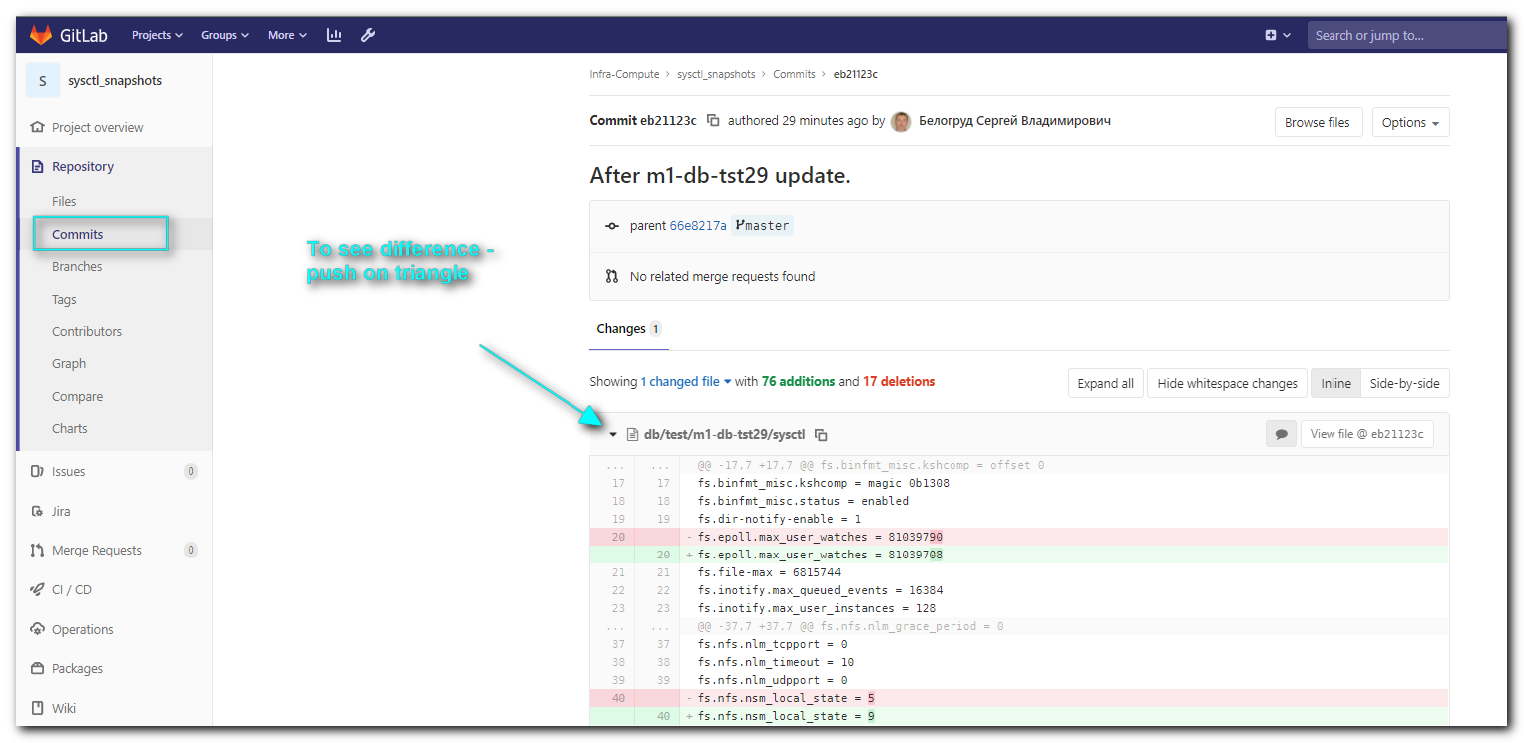

#
# After successful update - delete subscription, to save RedHat license.

# I think, command to remove license like this one. But Shevchenko Aleksandr
[11:18:19 root@m1-db-tst29 ~]# subscription-manager remove --all && subscription-manager unregister

# This is how it looks after subscription was removed from server.
[11:23:14 root@m1-db-tst29 ~]# subscription-manager status
+-------------------------------------------+
System Status Details
+-------------------------------------------+
Overall Status: Unknown

System Purpose Status: Unknown

[11:23:56 root@m1-db-tst29 ~]#

